Smart Robot Car for Autonomous Navigation: An IoT, MQTT, and Image Processing Approach

Author: XUAN KY PHAM

STUDENT ID: 1649932

Supervisor: DR. MELANIE OOI



Department of Electrical and Electronic Engineering UNIVERSITY OF WAIKATO

A thesis submitted to the University of Waikato by the requirements of the degree of MASTER OF ELECTRICAL AND ELECTRONIC ENGINEERING PRACTICE

July 2025

# Abstract

Robotic Autonomous navigation is an important technology in modern robotics nowadays, This enables vehicles to operate without human intervention. This thesis illustrates the design and implementation of a Smart Robot Car that utilizes IoT, MQTT, and image processing to achieve real-time navigation and control. The system integrates multiple hardware components, including an ESP32, Raspberry Pi, GPS NEO-8M module, BTS7960 motor driver, and various sensors to establish a combination system for robot car operation. IoT communication is established using the MQTT protocol, allowing seamless data exchange between the robot car and a remote server for monitoring and controlling the robot car. A PWM control algorithm is implemented to regulate motor speed and steering based on sensor inputs. Additionally, computer vision techniques are employed for obstacle detection and shutting down the robot in case the user sets any detection object in the safety range setting. Additionally, an image processing algorithm is utilized by YOLO V10 or YOLO V11 to control robot operations using traffic signs. The project also incorporates a web-based interface, developed using Flask and Python, as well as HTML, JavaScript, and PHP for real-time monitoring and remote command execution. The website was also designed to work on servers collecting data from Robot Car and control users remotely. The system is tested in various conditions to evaluate its navigation accuracy, response time, and overall efficiency. Results demonstrate that the combination of MQTT-based communication and real-time image processing significantly improves the robot’s ability to navigate autonomously. This research contributes to the field of IoT-based robotics by presenting a scalable and cost-effective approach to autonomous vehicle development. Future work may explore enhancements such as deep learning-based vision processing and cloud-based AI integration for improved decision-making and adaptability, as well as applying PID control Algorithms to regulate motor speed for the robot as a future improvement.

# Dedication and acknowledgments

I would like to extend my heartfelt gratitude to my supervisor, Professor Malenie Ooi, for her unwavering support, expert guidance, and encouragement throughout my research on the Robot Car. Her deep technical knowledge and insightful feedback have played a crucial role in shaping the direction of this dissertation

I am also grateful to the Faculty of Electrical and Electronic Engineering department of Waikato University for providing the necessary resources Nikobot and an excellent research environment to complete this project.

Having valuable feedback from laboratory staff and some tutors at Waikato University is important information that allowed me to update my operation program during the test of the robot car project. Their collaboration and insights have enriched this research significantly.

Moreover, the support and motivation from my family are some of the biggest factors that enable me to thrive in the academic research project. Their belief in me has been a driving force in successfully completing this work.

Finally, I acknowledge the contributions of the open-source community, such as Python and Arduino libraries. Those resources and shared knowledge in IoT, MQTT, and image processing have been invaluable in implementing the Smart Robot Car project.

Xuan Ky Pham June 2025

# Author’s declaration

I, Xuan Ky Pham, do solemnly declare that this thesis, "Smart Robot Car for Autonomous Navigation: An IoT, MQTT, and Image Processing Approach," is my work and has not been submitted, either wholly or partially, for any other academic qualification or degree at any other institution or university.

This work was for the Master's degree in Electrical and Electronic Engineering Practice at Waikato University, New Zealand. The contents of this thesis are the result of my studying from resources from many places and contributions from Students who made NIKOBOT to give me a good robot for improving the control system, except where due acknowledgment of the work of other authors has been mentioned. Due citations and acknowledgments have been made wherever required.

I declare that this thesis conforms to Waikato University's ethical standards and academic integrity processes. I accessed any experimental data, software, or technical packages presented in this research through my research work, and all external sources of help have been properly acknowledged.

I take full responsibility for any errors or omissions contained in this document.

Signature:

Xuan Ky Pham

Date: June 2025

## Table of Contents

**Page**

1. Chapter 1 Introduction 1
   1. Background . . . . . . . . . . . . . . . . . . . . . . . . . . . . . . . . . . . . . . . . . . . . 1
   2. Problem Statement and Motivation . . . . . . . . . . . . . . . . . . . . . . . . . . . . . . . . 1
   3. Research Objectives . . . . . . . . . . . . . . . . . . . . . . . . . . . . . . . . . . . . . . . . 1
   4. Scope and Limitations . . . . . . . . . . . . . . . . . . . . . . . . . . . . . . . . . . . . . . 2
   5. Thesis Structure . . . . . . . . . . . . . . . . . . . . . . . . . . . . . . . . . . . . . . . . . . 2
2. Chapter 2 Literature Review 3
   1. Introduction . . . . . . . . . . . . . . . . . . . . . . . . . . . . . . . . . . . . . . . . . . . . 3
   2. Previous Research on Robot Cars . . . . . . . . . . . . . . . . . . . . . . . . . . . . . . . . . 3
      1. Evolution of Autonomous Robot Cars . . . . . . . . . . . . . . . . . . . . . . . . . . 3
      2. Key Technologies in Autonomous Robotics . . . . . . . . . . . . . . . . . . . . . . . 3
   3. IoT in Autonomous Robotics . . . . . . . . . . . . . . . . . . . . . . . . . . . . . . . . . . . 3
      1. Applications of IoT in Robot Cars . . . . . . . . . . . . . . . . . . . . . . . . . . . . 4
      2. Challenges in IoT-based Robotics . . . . . . . . . . . . . . . . . . . . . . . . . . . . 4
   4. MQTT Communication Protocol (source: https://aws.amazon.com/what-is/mqtt/) . . . . . . . 4
      1. What is MQTT? . . . . . . . . . . . . . . . . . . . . . . . . . . . . . . . . . . . . . 4
      2. Why is the MQTT protocol important? . . . . . . . . . . . . . . . . . . . . . . . . . 4
      3. What is the history behind MQTT protocol? . . . . . . . . . . . . . . . . . . . . . . . 5
      4. What is the principle behind MQTT? . . . . . . . . . . . . . . . . . . . . . . . . . . 5
      5. What are MQTT components? . . . . . . . . . . . . . . . . . . . . . . . . . . . . . . 5
      6. How does MQTT work? . . . . . . . . . . . . . . . . . . . . . . . . . . . . . . . . . 6
      7. What is MQTT over WSS? . . . . . . . . . . . . . . . . . . . . . . . . . . . . . . . . 6
      8. Application of MQTT . . . . . . . . . . . . . . . . . . . . . . . . . . . . . . . . . . 6
   5. WebSocket Protocol . . . . . . . . . . . . . . . . . . . . . . . . . . . . . . . . . . . . . . . . 7
      1. What is WebSocket? . . . . . . . . . . . . . . . . . . . . . . . . . . . . . . . . . . . 7
      2. What makes WebSocket a good fit for real-time communication? . . . . . . . . . . . . 7
   6. Comparison of MQTT and WebSocket protocol . . . . . . . . . . . . . . . . . . . . . . . . . 8
   7. Image Processing for Autonomous Navigation . . . . . . . . . . . . . . . . . . . . . . . . . . 8
      1. Techniques in Robotics for Seeing . . . . . . . . . . . . . . . . . . . . . . . . . . . . 9
      2. Using Deep Learning to Process Pictures . . . . . . . . . . . . . . . . . . . . . . . . 9
      3. What’s Tough About Robots Processing Images . . . . . . . . . . . . . . . . . . . . . 10
   8. Existing Methodologies and Their Limitations . . . . . . . . . . . . . . . . . . . . . . . . . 10
   9. How This Research Advances the Field 12

|  |  |  |
| --- | --- | --- |
| **3** | **Chapter 3 System Design and Architecture** | **15** |
|  | 3.1 Hardware Components . . . . . . . . . . . . . . . . . . . . . . . . . . . . . . . . . . . . . . | 15 |
|  | 3.1.1 ESP32 . . . . . . . . . . . . . . . . . . . . . . . . . . . . . . . . . . . . . . . . . . | 15 |
|  | 3.1.2 Raspberry PI 3B+ . . . . . . . . . . . . . . . . . . . . . . . . . . . . . . . . . . . . | 18 |
|  | 3.1.3 RPLidar C1 . . . . . . . . . . . . . . . . . . . . . . . . . . . . . . . . . . . . . . . | 19 |
|  | 3.1.4 Intel Realsens Depth Camera . . . . . . . . . . . . . . . . . . . . . . . . . . . . . . | 21 |
|  | 3.1.5 DC Motor Driver BTS7960 . . . . . . . . . . . . . . . . . . . . . . . . . . . . . . . | 22 |
|  | 3.1.6 PS2 Remote 2.4Ghz and receiver . . . . . . . . . . . . . . . . . . . . . . . . . . . . | 24 |
|  | 3.1.7 Lora 433Mhz SX-1278 . . . . . . . . . . . . . . . . . . . . . . . . . . . . . . . . . | 24 |
|  | 3.1.8 IoT Spectrum in New Zealand . . . . . . . . . . . . . . . . . . . . . . . . . . . . . . | 25 |
|  | 3.2 Software Components . . . . . . . . . . . . . . . . . . . . . . . . . . . . . . . . . . . . . . . | 24 |
|  | 3.2.1 Arduino IDE . . . . . . . . . . . . . . . . . . . . . . . . . . . . . . . . . . . . . . . | 26 |
|  | 3.2.2 Python . . . . . . . . . . . . . . . . . . . . . . . . . . . . . . . . . . . . . . . . . . | 27 |
|  | 3.2.3 Visual Studio Code, HTML Javascript and PHP . . . . . . . . . . . . . . . . . . . . . | 28 |
|  | 3.2.4 MIT APP . . . . . . . . . . . . . . . . . . . . . . . . . . . . . . . . . . . . . . . . . | 29 |
|  | 3.3 Architecture and Schematics . . . . . . . . . . . . . . . . . . . . . . . . . . . . . . . . . . . | 31  3.3.1 |
|  | 3.3.1 Robot car Architecture ……………………………………………………………………. | 31 |
|  | 3.3.2 Robot Schematic …………………………………………………………………………. | 31 |
|  | 3.4 Networking and IoT Integration . . . . . . . . . . . . . . . . . . . . . . . . . . . . . . . . . | 33 |
|  | 3.4.1 Webserver on ESP32 . . . . . . . . . . . . . . . . . . . . . . . . . . . . . . . . . . | 34 |
|  | 3.4.2 Webserver on RPI . . . . . . . . . . . . . . . . . . . . . . . . . . . . . . . . . . . . | 36 |
|  | 3.4.3 Webserver on PC . . . . . . . . . . . . . . . . . . . . . . . . . . . . . . . . . . . . . | 37 |
|  | 3.4.4 Webserver on Internet . . . . . . . . . . . . . . . . . . . . . . . . . . . . . . . . | 38 |

1. **Chapter 4 Implementation** **40**
   1. Hardware Assembly 40
      1. Wiring and Circuit Design 40
   2. Software Development 38
      1. Code Structure 40
      2. Communication over MQTT and WebSocket 41
   3. Algorithm Development 41
      1. PID Control for Motor Speed 41
      2. Image Processing for Navigation 42
   4. Data Flow and Communication 42
      1. Message Passing Between IoT Devices 42
      2. Real-Time Feedback Loop 42
2. **Chapter 5 Experimental Setup and Testing** **43**
   1. Description of Test Environment 43
   2. Performance Analysis 43
      1. PS2 Remote Performance Test 43
      2. Motor Performance and Current Measurement 43
      3. Obstacle Detection and Avoidance 44
   3. Real-Time Response Testing and IoT Connectivity 44
      1. Results 44
   4. Image Processing Accuracy Assessment 44
      1. Object Detection and Distance Estimation 45
      2. Findings 45
   5. Battery Performance Evaluation 45
3. **Chapter 6 Result and Discussion** **46**
   1. System Performance Analysis 46
   2. Graphs, tables, and comparisons 46

6.2.1 Motor Speed and PWM input 47

6.2.2 Obstacle detection and distance accuracy 48

6.2.3 PS2 Remote testing 48

6.2.4 Ultrasonic Sensor distance testing 49

6.2.5 RPlidar testing 49

6.2.6 Test robot operation using python application 50

* 1. Limitations and improvements 51
  2. Future Enhancement 52

1. **Chapter 7: Conclusion and Future Work** **53**
   1. Conclusion 53
   2. Future works 53

8. Appendix 54

# List of abbreviations

Abbreviation Definition

MQTT Message Queuing Telemetry Transport

YOLO YOU LOOK ONLY ONE from Ultralytics

SSDs Single Shot Detectors

CNN Convolution Neural Network

AI Artificial Intelligent

IOT Internet Of Things

GPS Global Position System

TCP Transmission Control Protocol

TLS Transport Layer Security

CoAP The Constrained Application Protocol (CoAP)

OASIS Organization for the Advancement of Structured Information Standards

LoRa Long Range

## List of Tables

**TABLE Page**

Table 1: Comparison between MQTT and WebSocket 9

Table 2: Specification of RPI 3B+ 18

Table 3: Specification of RPI 5 19

Table 4: DC motor controller BST-7960 specification 23

Table 5: DC Motor control wiring pin 24

Table 6: DC Motor power and Motor wiring pin 24

Table 7: Lora SX-1278 specification 25

Table 8: Lora SX-1278 frequency range 26

Table 9: Measuring Motor speed left and right based on PWM Input 47

Table 10: Intel Realsens camera performance test 48

Table 11: Ultrasonic Sensor Performance Test 49

## List of Figures

**FIGURE Page**

Figure 1: Component of MQTT 5

Figure 2: Application of IoT MQTT in Industries 7

Figure 3: NIKOBOT Waikato University 2021 11

Figure 4: Hardware Overview NIKOBOT 2021 12

Figure 5: Hardware overview for robot car 2025 13

Figure 6: Nikobot FWD Waikato University 2025 14

Figure 7: Nikobot AFT Waikato University 2025 14

Figure 8: Hardware component Nikobot 2025 15

Figure 9: ESP32 Hardware Specifications 16

Figure 10: Raspberry PI 3B+ 18

Figure 11: Raspberry PI 5 18

Figure 12: RPLidar C1 20

Figure 13: Working Mode RPlidar C1 21

Figure 14: Intel Realsense Depth Camera D455 21

Figure 15: DC Motor Driver BTS-7960 22

Figure 16: Motor driver BTS-7960 power supply and motor pin 23

Figure 17: Yahboom PS2 Remote 24

Figure 18: Lora SX-1278 25

Figure 19: IoT Spectrum requirement in New Zealand 25

Figure 20: Screenshot of Arduino IDE Software 27

Figure 21: Screenshot of Pycharm Software for Python programming 28

Figure 22: Screenshot of Visual Studio code software 29

Figure 23: Screenshot of MIT Application software for robot car 30

Figure 24: Architecture diagram for robot car 31

Figure 25: Schematic diagram for robot car 32

Figure 26: Web pages for Python Flask application 33

Figure 27: Web pages for ESP32 HTML and JavaScript 33

Figure 28: Web pages on ESP32 34

Figure 29: ESP32 webserver stored in File system memory 34

Figure 30 ESP32 Webserver stored in program memory 35

Figure 31 Accessing web server on ESP32 36

Figure 32: Accessing the web server on Raspberry PI 36

Figure 33: Accessing the web server on local PC (Python flask) 37

Figure 34: Flask webserver at local pc 38

Figure 35: Accessing Webserver of robot car on internet 39

Figure 36: Motor speed left and right RPM speed differences from 14 to 37 RPM 47

Figure 37: Motor speed left and right RPM changing 48

Figure 38: Yahboom 2.4GHz PS2 remote 49

Figure 39: Rplidar performance test 50

Figure 40: Python interface program 50

Figure 41: Images Dataset for traffic signal 51

## Chapter 1 Introduction

### Background

The development of the Internet of Things (IoT), Message Queuing Telemetry Transport (MQTT), and image processing have greatly influenced the current practice in modern robotics. IoT technology makes it possible to have a cloud that enables robots to work autonomously by using data in real time. MQTT is a lightweight publish/subscribe messaging protocol that has been adopted in IoT applications because it can provide fast and reliable communication between devices. Meanwhile, image processing improves the autonomy of navigation by providing robots with a sense of their surroundings. In autonomous vehicles and robotic systems, IoT is crucial in data collection and management and remote monitoring, while MQTT provides high efficiency and real-time communication. Robots’ performance is enhanced by image processing techniques combined with artificial intelligence to identify hazards and objects and navigate through the environment. These technologies find their integration particularly important in the creation of autonomous robot cars that need to move with precision and without endangering their surroundings. The current thesis describes the creation of a smart robot car that can move autonomously using IoT, MQTT, and image processing. The system uses Raspberry Pi, a GPS NEO-8M module, BTS7960 motor drivers, and other hardware components to support real-time decision-making and control. By using MQTT for communication and computer vision for navigation, this project seeks to create a scalable and efficient autonomous robotic system.

### Problem Statement and Motivation

The use of autonomous robotic vehicles is capturing the interest of industries dealing with smart transportation, industry automation, and surveillance. Nevertheless, achieving reliable autonomous navigation has communication delays, sensor fusion, and real-time decision-making as obstacles. Other movements such as these have led to the development of different solutions on the Internet of Things that offer better movement and remote management features for everyday devices such as need.

Also, for communication between the robot and supervisory systems to be effective, efficient and low-power protocols have to be employed. With its low overhead configuration and perfect optimization in constrained networks, MQTT is perfect for real-time communications in IoT-enabled robotic systems. Furthermore, the implementation of computer vision allows the robot to detect obstacles, follow the desired path, and decide where to go, increasing the robot’s autonomy.

The main aim of this research is an autonomous robotic car that a user can easily control and monitor using IoT and image processing techniques to improve the system's decision-making capabilities. Use cases for this system include autonomous delivery machines, patrol robots, and smart cars.

### Research Objectives

This study aims to achieve the following:

To create an autonomous robot car powered by IoT and communicate through MQTT in real time.

To devise a motor control system based on PWM regulation for improved movement precision and stability.

To apply image processing for efficient obstacle recognition and course direction.

To create an interface hosted on the web on Flask framework for remote control and monitoring of the robot

car.

To assess the performance of the system with respect to its navigational accuracy, communication accuracy,

and its ability to make decisions in real time.

### Scope and Limitations

**Scope**

This project is concerned with the design and implementation of an intelligent robotic car using the Internet of Things technologies, MQTT protocol, and image processing techniques. Raspberry Pi will be used as the MQTT Broker and Webserver for the system, enabled for real-time communication. The navigation control will use PWM parameters to control the speed of the motors and image processing will be used for obstacle and command for navigation from image traffic signs. The project will also include a web-based control interface for remote supervision.

**Limitations**

The system has its merits, but it also suffers from the following shortcomings.

Raspberry Pi limited processing capabilities: The deep learning models will not be able to work in real-time due to resource constraints on the Raspberry Pi so we use a PC or Laptop in the process of image processing and send video from a webcam over the internet or local network.

Environmental considerations: Obstruction of the cameras as well as the amount of light present will impact the efficacy of image processing.

Network-reliant: The stability and speed of the network determine the efficacy of MQTT communication.

Limited battery life: Data computation and message communication may result in high energy expenditure, leading to deterioration of the battery life.

### Thesis Structure

The following describes how this thesis is organized:

Chapter 1 Introduction: It illustrates the background information, the status of the research problem, and some research objectives. The scope and delimitations are also discussed in this section, and the thesis outline is described.

Chapter 2 Literature Review: It describes what has been done in IoT-based autonomous vehicles, MQTT communication protocol, WebSocket protocol, and image processing in robotics.

Chapter 3 System Design and Architecture: This chapter will illustrate the software and hardware components of a smart robot car.

Chapter 4 Implementation: Chapter 4 contains the details of IoT, MQTT, WebSocket, and image processing modules that were implemented step-by-step.

Chapter 5 Experimental Setup and Testing: This chapter describes the methodology for testing the system and its components after implementation.

Chapter 6 Results and Discussion: This chapter will show how well the system works in terms of efficiency, the accuracy of the robot car’s navigation, and the integration of the various components.

Chapter 7 Conclusion and Future Work: The main conclusions of the research will be mentioned as the achievement of the research, and the action taken to improve this project in future work.

## Chapter 2 Literature Review

### Introduction

The development of autonomous robot cars has been an area of significant research due to advancements in the Internet of Things (IoT), MQTT communication, and image processing. This chapter reviews existing literature on these technologies, discussing their applications in robotics and identifying limitations in previous methodologies. Additionally, this chapter explores how this research advances the field by integrating IoT, MQTT, and image processing into an efficient and scalable smart robot car.

### Previous Research on Robot Cars

Self-driving cars have captured the attention of researchers for their potential in transportation, factory automation, and intelligent monitoring. The first studies looked at basic robots that followed lines, which depended on infrared sensors to stay on a set course. However, newer research has brought in cutting-edge computer vision and machine learning to boost how these vehicles find their way and make choices with real-time IoT communication (MQTT) to send and receive commands to and from the controller.

#### Evolution of Autonomous Robot Cars

Robot cars have developed in stages, from basic manual models to smart self-driving systems powered by AI. First-generation robot cars – An Early robot car was designed in 2021 by two Waikato University students, using simple microcontrollers, Arduino Mega 2560, combined with a 2.4GHz remote controller.

These setups used pulse width modulation (PWM) to spot button presses and control how fast motors moved and the robot car's direction. While these systems could handle basic moves, they couldn’t navigate on their own.

Second-generation robot cars 2025 – When GPS and many sensors came along, robot cars started to navigate by themselves in simple ways. They added ultrasonic and infrared sensors to Ultrasonic sensor to detect the distance of obstacles, RPLidar to scan the obstacle distance in 360 degrees around the robot car.

Modern robot cars in the future – New studies have combined AI, IoT, and real-time image processing to make self-driving possible. These systems use computer vision, deep learning, and MQTT-based communication to allow for remote checks and quick choices.

#### Key Technologies in Autonomous Robotics

IoT-enabled robot cars – Research has looked into using IoT to control and keep an eye on robot cars from afar. MQTT for real-time communication – Studies have shown that MQTT works better than HTTP for IoT-

Based on robot projects.

### IoT in Autonomous Robotics

The Internet of Things (IoT) has a significant impact on the growth of connected robotic systems. IoT lets devices talk and share information, making it possible to watch and control robotic vehicles from afar.

#### Applications of IoT in Robot Cars

A web server or Android application enables remote checks to keep things running, cutting down on breakdowns. Sensors, controllers, and outside servers often share data using MQTT or WebSocket. These methods work well with low bandwidth and power, allowing cars to drive together and get traffic updates right away. GPS and IoT methods help track vehicles in real time, making logistics and operations more effective.

#### Challenges in IoT-based Robotics

Network dependency: Robots that use IoT need steady internet connections, which limits where they can work in areas with bad network coverage. Security concerns – Sending data over IoT networks can be risky. Hackers might try to intercept data, steal information, or disrupt services. This could mess with how the vehicle is controlled or expose personal information. To tackle these issues, it’s key to use strong encryption, check who’s accessing the system, and look for security weak spots.

Power consumption: Robots with IoT features use up more power because they’re always sending data. To use less energy, it helps to send data less often and use hardware that doesn’t need as much power. What’s coming next? We’ll see 5G and edge computing join forces with IoT robots. This combo will help reduce delays and make the robots respond faster in real time.

The mechanical front wheel design is also one of the challenging factors affecting the robot's direction control and position control for the robot car. In this designed robot, we used castor wheels, so it takes some time to keep the robot moving straight due to the small difference between the left and right motor speed adjustments.

### MQTT Communication Protocol [4]

#### What is MQTT?

MQTT is a standards-based messaging protocol, or set of rules, used for machine-to-machine communication. Smart sensors, wearables, and other Internet of Things (IoT) devices typically have to transmit and receive data over a resource-constrained network with limited bandwidth. These IoT devices use MQTT for data transmission as it is easy to implement and can communicate IoT data efficiently. MQTT supports messaging between devices to the cloud and the cloud to the device.

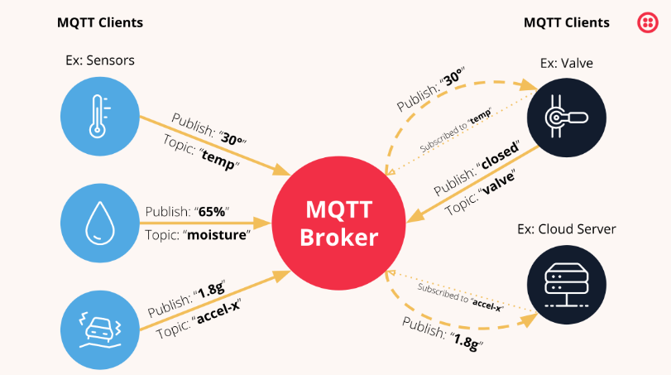

Figure 1: Component of MQTT protocol (source:https://www.twilio.com/en-us/blog/what-is-mqtt)

#### Why is the MQTT protocol important?

The MQTT protocol has become a standard for IoT data transmission because it delivers the following benefits:

Lightweight and efficient MQTT implementation on the IoT device requires minimal resources, so it can even be used on small microcontrollers. For example, a minimal MQTT control message can be as little as two data bytes. MQTT message headers are also small so that you can optimize network bandwidth.

Scalable MQTT implementation requires a minimal amount of code that consumes very little power in operations. The protocol also has built-in features to support communication with a large number of IoT devices. Hence, you can implement the MQTT protocol to connect with millions of these devices.

Reliable Many IoT devices connect over unreliable cellular networks with low bandwidth and high latency. MQTT has built-in features that reduce the time the IoT device takes to reconnect with the cloud. It also defines three different quality-of-service levels to ensure reliability for IoT use cases— at most once (0), at least once (1), and exactly once (2).

Secure MQTT makes it easy for developers to encrypt messages and authenticate devices and users using modern authentication protocols, such as OAuth, TLS1.3, customer-managed certificates, and more.

Well-supported Several languages like Python have extensive support for MQTT protocol implementation.

Hence, developers can quickly implement it with minimal coding in any type of application.

#### What is the history behind MQTT protocol?

The MQTT protocol was invented in 1999 for use in the oil and gas industry. Engineers needed a protocol for minimal bandwidth and minimal battery loss to monitor oil pipelines via satellite. Initially, the protocol was known as Message Queuing Telemetry Transport due to the IBM product MQ Series that first supported its initial phase. In 2010, IBM released MQTT 3.1 as a free and open protocol for anyone to implement, which was then submitted, in 2013, to the Organization for the Advancement of Structured Information Standards (OASIS) specification body for maintenance. In 2019, an upgraded MQTT version 5 was released by OASIS. Now, MQTT is no longer an acronym but is considered to be the official name of the protocol.

#### What is the principle behind MQTT?

The MQTT protocol works on the principles of the publish/subscribe model. In traditional network communication, clients and servers communicate with each other directly. The clients request resources or data from the server, and then the server processes and sends back a response. However, MQTT uses a publish/subscribe pattern to decouple the message sender (publisher) from the message receiver (subscriber). Instead, a third component, called a message broker, handles the communication between publishers and subscribers. The broker’s job is to filter all incoming messages from publishers and distribute them correctly to subscribers. The broker decouples the publishers and subscribers as below:

Space decoupling the publisher and subscriber are not aware of each other’s network location and do not exchange information such as IP addresses or port numbers.

Time decoupling the publisher and subscriber don’t run or have network connectivity at the same time.

Synchronization decoupling Both publishers and subscribers can send or receive messages without interrupting each other. For example, the subscriber does not have to wait for the publisher to send a message.

#### What are MQTT components?

MQTT implements the publish/subscribe model by defining clients and brokers as below.

MQTT client An MQTT client is any device from a server to a microcontroller that runs an MQTT library. If the client is sending messages, it acts as a publisher, and if it is receiving messages, it acts as a receiver. Basically, any device that communicates using MQTT over a network can be called an MQTT client device.

MQTT broker The MQTT broker is the backend system that coordinates messages between the different clients. The responsibilities of the broker include receiving and filtering messages, identifying clients subscribed to each message, and sending them the messages. It is also responsible for other tasks such as:

Authorizing and authenticating MQTT clients Passing messages to other systems for further analysis Handling missed messages and client sessions MQTT connection Clients and brokers begin communicating by using an MQTT connection. Clients initiate the connection by sending a CONNECT message to the MQTT

broker. The broker confirms that a connection has been established by responding with a CONNACK message. Both the MQTT client and the broker require a TCP/IP stack to communicate. Clients never connect with each other, only with the broker.

#### How does MQTT work?

An overview of how MQTT works is given below.

An MQTT client establishes a connection with the MQTT broker. Once connected, the client can either publish messages, subscribe to specific messages, or do both. When the MQTT broker receives a message, it forwards it to subscribers who are interested. Let’s break down the details for further understanding.

MQTT topic: The term ‘topic’ refers to keywords the MQTT broker uses to filter messages for the MQTT clients. Topics are organized hierarchically, similar to a file or folder directory. For example, consider a smart home system operating in a multilevel house that has different smart devices on each floor. In that case, the MQTT broker may organize topics as:

ourhome/groundfloor/livingroom/light ourhome/firstfloor/kitchen/temperature

MQTT publish MQTT clients publish messages that contain the topic and data in byte format. The client determines the data format, such as text data, binary data, XML, or JSON files. For example, a lamp in the smart home system may publish a message on the topic livingroom/light.

MQTT subscribe MQTT clients send a SUBSCRIBE message to the MQTT broker to receive messages on topics of interest. This message contains a unique identifier and a list of subscriptions. For example, the smart home app on your phone wants to display how many lights are on in your house. It will subscribe to the topic light and increase the counter for all on messages.

#### What is MQTT over WSS? [5]

MQTT over WebSockets (WSS) is an MQTT implementation to receive data directly into a web browser. The MQTT protocol defines a JavaScript client to provide WSS support for browsers. In this case, the protocol works as usual, but it adds additional headers to the MQTT messages to also support the WSS protocol. You can think of it as the MQTT message payload wrapped in a WSS envelope.

Is MQTT secure? MQTT communication uses the SSL protocol to protect sensitive data transmitted by IoT devices. You can implement identity, authentication, and authorization between clients and the broker using SSL certificates and/or passwords. The MQTT broker typically authenticates clients using their passwords as well as unique client identifiers it allocates to each client. In most implementations, the client authenticates the server with certificates or DNS lookups. You can also implement encryption protocols with MQTT.

#### Application of MQTT [3]

MQTT used in various applications in industries and home automation nowadays, this protocol become very popular in industries as well as home automation. Such as Auto Transportation, Logistic, Manufacturing, Smart Home, and so on.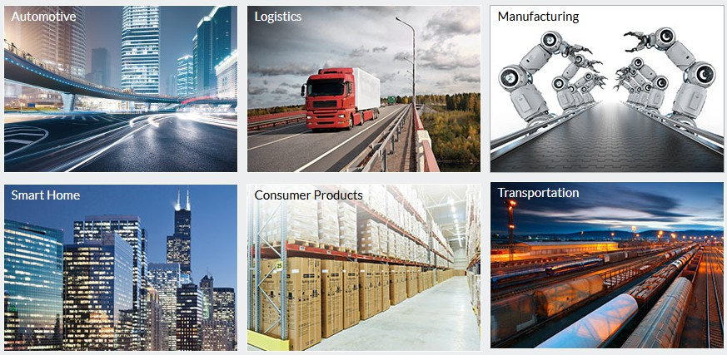

Figure 2: Application of IoT MQTT in industries ( source: https://mqtt.org/)

### WebSocket Protocol [6]

#### What is WebSocket?

The WebSocket protocol enables full-duplex interaction between a web browser (or other client application) and a web server with lower overhead than half-duplex alternatives such as HTTP polling, facilitating real-time data transfer from and to the server. This is made possible by providing a standardized way for the server to send content to the client without being first requested by the client and allowing messages to be passed back and forth while keeping the connection open. In this way, a two-way ongoing conversation can take place between the client and the server

That widespread availability makes WebSocket a straightforward choice for real-time communication in web applications. Once you have server-side support for WebSocket, it takes relatively little effort to apply the protocol to communication with mobile apps, other devices, and even microservices.

But there’s more to WebSocket than its ubiquity.

#### What makes WebSocket a good fit for real-time communication?

WebSocket grew out of a need to overcome the constraints of HTTP’s client-initiated request-response model. The web applications we use today need the ability to push data from the server to the browser whenever they choose, not only when the client opens a connection. As such, WebSocket matches the typical one-to-one connection between a web application and a server.

In particular, the benefits of WebSocket are:

Available almost everywhere: It’s worth repeating that WebSocket is available in every modern web browser, meaning you don’t need to ask users to install anything on their side.

Simple: Once you’ve established a connection, sending messages in either direction is straightforward. That makes it easy to build advanced functionality and other messaging patterns, such as publish/subscribe, on top of WebSocket.

Low-latency: WebSocket message headers tend to be 2 bytes long, which avoids waste and improves the sense of real-time communication.

### Comparison of MQTT and WebSocket protocol [6]

|  |  |  |
| --- | --- | --- |
| MQTT and WEBSOCKET | | |
| Criteria | MQTT | WebSocket |
| Use cases | MQTT is suitable for low-powered devices with limited CPU and memory and unreliable, low bandwidth networks. It’s the go-to protocol for IoT use cases. | WebSockets are suitable for web apps and devices unrestricted (or less restricted) by low bandwidth, which are compatible for use cases such as financial tickers, online multiplayer games, chat, geolocation updates, live polls, etc. |
| Message distribution | One-to-many | One-to-one |
| Architecture | MQTT uses a publish/subscribe messaging pattern. | Bidirectional, socket-like API. Note: Many WebSocket frameworks and libraries add pub/sub capabilities on top of WebSockets. |
| Messaging QoS | MQTT has three QoS (quality of service) options: 0 (at most once delivery), 1 (at least once delivery), and 2 (exactly-once delivery). | Raw WebSockets don’t provide QoS options. |
| Underlying protocol | TCP | TCP |
| Messaging mode | Asynchronous, event-based | Asynchronous, event-based |
| Message size | Maximum of 256 MB | Theoretically 263 bytes per frame. |
| Secure connections | TLS | TLS |
| Message overhead | Minimum of 2 bytes | Minimum of 2 bytes for all messages except masked frames, which have a  minimum of 6 bytes. |
| Message queuing | MQTT brokers queue messages for all disconnected clients subscribed to a  topic. | Raw WebSocket doesn’t support message queuing. |

Table 1: Comparison MQTT and WebSocket protocol Ref: https://ably.com/topic/mqtt-vs-websocket

### Image Processing for Autonomous Navigation

Image recognition is very popular nowadays, it allows robot cars to recognize objects, detect types of obstacles, and make decisions regarding navigation in real time. The integration of computer vision and deep learning has improved significantly in autonomous navigation for robot cars.

#### Techniques in Robotics for Seeing

Robots use 2 cameras forward. An Intel Realsense Depth Camera D455 is used to detect objects and the distance from objects from the robot car to determine whether the robot needs to move forward or stop immediately in the range of safety distance that parameter setting by user.

The second camera is Logitect Webcam, which can be used for traffic sign detection, including move forward, backward, left, right, or stop, as well as change motor speed using traffic sign speed limit. These datasets were trained by YOLO V11. Another function for this camera we can use a normal camera to stream video information of a Car and send this image over a local network or the internet using MQTT Protocol with low bandwidth, low resolution of images.

#### Using Deep Learning to Process Pictures

#### "YOLO" can spot stuff super quick. [2]

Ultralytics YOLO11, the latest version of the acclaimed real-time object detection and object prediction model. YOLO11 is built on cutting-edge advancements in deep learning and computer vision, offering unparalleled performance in terms of speed and accuracy. Its streamlined design makes it suitable for various applications and easily adaptable to different hardware platforms, from edge devices to cloud APIs. Document

#### "SSD" keeps it simple but is good at spotting stuff, too. [7]

Single Shot Detectors (SSDs) are a popular and efficient method for object detection. They use a single convolutional neural network (CNN) to predict bounding boxes and class labels for objects in an image, making them faster and more efficient than other methods.

**"CNNs" are great for sorting images and getting the big picture. [8]**A convolutional neural network (CNN) is a category of machine learning models. Specifically, it is a type of deep learning algorithm that is well suited to analyzing visual data. CNNs are commonly used to process image and video tasks. And, because CNNs are so effective at identifying objects, they are frequently used for computer vision tasks, such as image recognition and object recognition, with common use cases including self-driving cars, facial recognition, and medical image analysis.

#### What’s Tough About Robots Processing Images

Robots have to decode the visual information.

Image handling needs strong processing due to the "computational overhead."

When it gets dark, the system doesn’t work as well because it’s hooked on good lighting.

Mistakes in figuring out what’s what can mess up how it moves, which is what we call "false detections."

### Existing Methodologies and Their Limitations

The existing robot car controller is built around the Arduino Mega 2560, which is responsible for managing both DC motors and interpreting PWM pulse width signals from a 2.4GHz RF remote to control the car’s movement. In addition to handling motor control, the Arduino Mega also reads data from two encoders and current sensors attached to the motors. However, despite collecting this sensor data, the system does not actively use it for real-time decision-making or safety measures. Instead, the sensor readings are primarily used for monitoring and

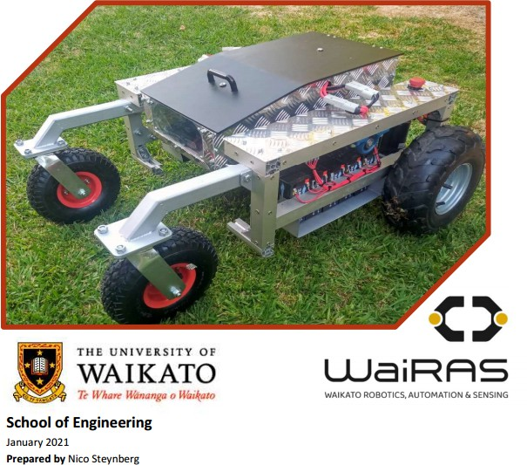measurement purposes rather than for implementing any form of automatic prevention or obstacle avoidance mechanisms to enhance the robot’s safety and performance.

Figure 3 : Nikobot Waikato University 2021

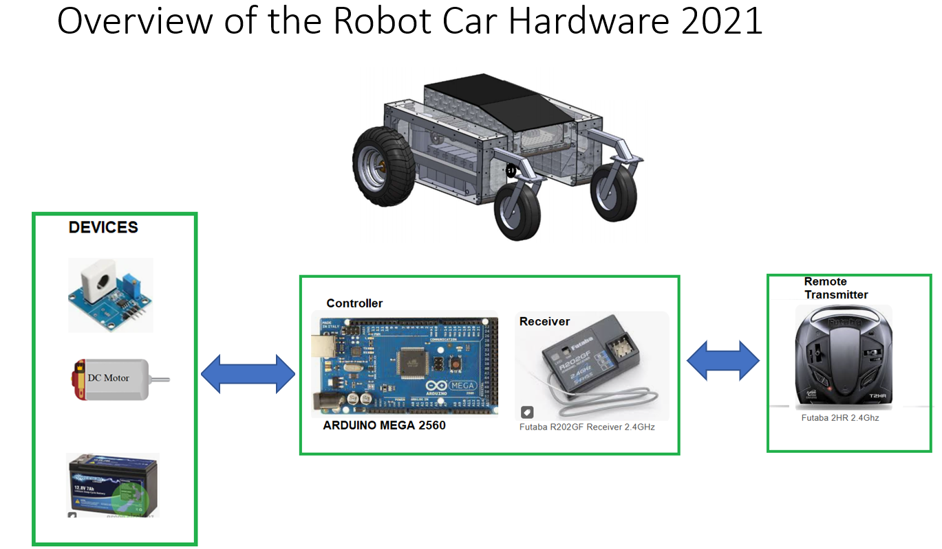

Figure 4: Hardware overview for Robot Car 2021 (NIKOBOT)

### How This Research Advances the Field

The robot car now has better solutions because of the use of IoT protocol MQTT in the communication, and it can also process images. It can recognize objects and figure out how far away they are. This new feature means the robot car will stop when it spots something in its path within a set safe distance. This makes the car safer and better at avoiding things in its way. What’s more, the robot now has an RPLidar that scans for obstacles in all directions. This sensor sends data to the computer to indicate the distance of the robot in the round of 360o so that the program will check the distance surroundings and stop moving if it spots something too close. To make the obstacle detection even better, the vehicle also has ultrasonic sensors on its front and back. These add an extra layer of safety by making the car stop when they detect something blocking its way. Finally, two cameras are installed for object detection and measuring distance to stop the car at a safe distance, A Logitech camera can be used for traffic sign detection combined with a python program to send commands to operate the robot car.

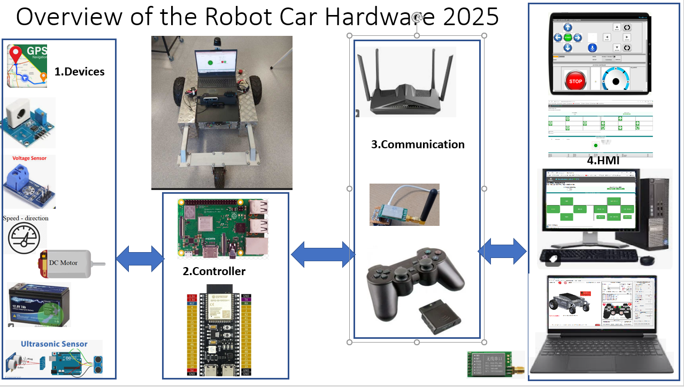

Figure 5: Hardware overview for robot car version 2025

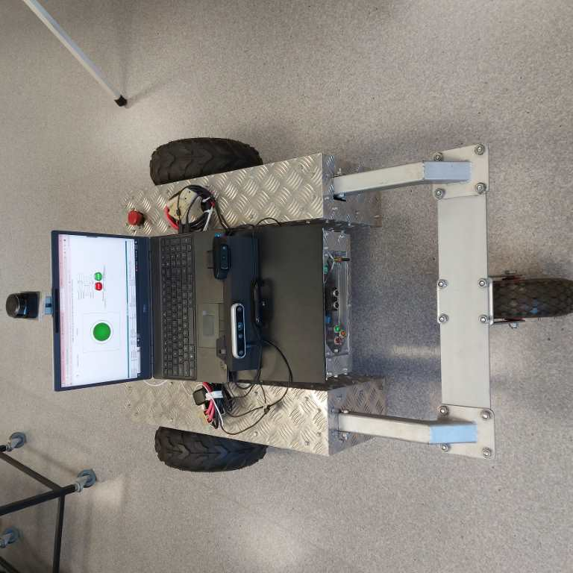

Figure 6 : Nikobot FWD Waikato University 2025

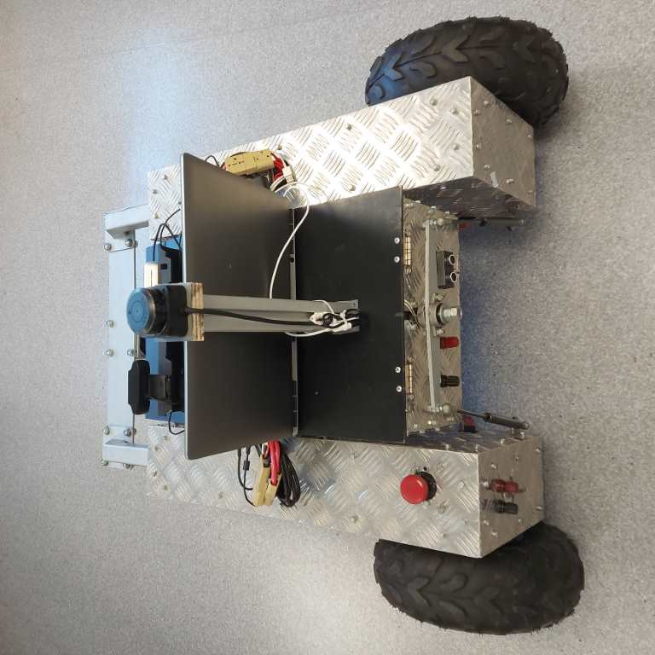

Figure 7: Nikobot AFT Waikato University 2025

## Chapter 3 System Design and Architecture

### Hardware Components

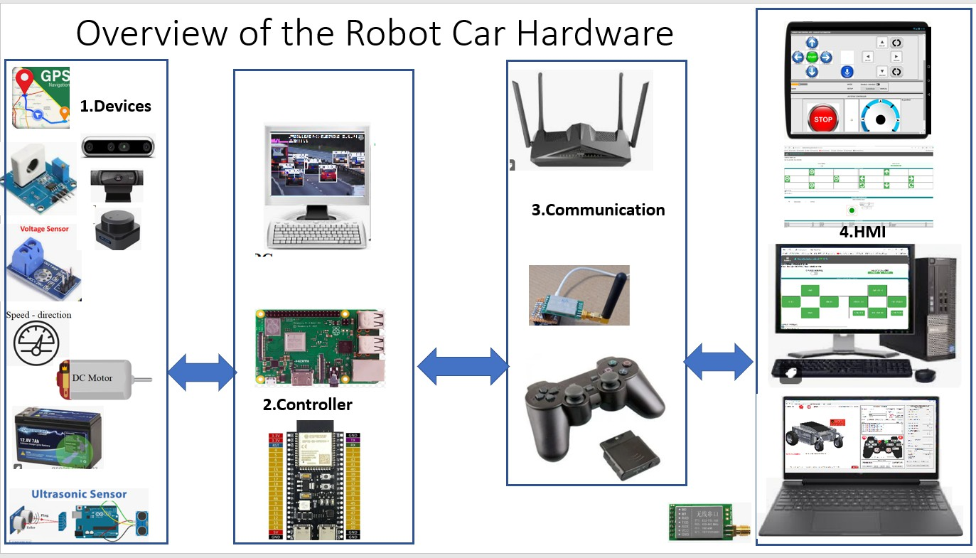

Figure 8 : Nikobot Waikato University 2025 Hardware Components

#### ESP32 [13]

ESP32-S3-WROOM-1

2.4 GHz Wi-Fi (802.11b/g/n) and Bluetooth® 5 module

Built around ESP32-S3 series of SoCs, Xtensa® dual-core 32-bit LX7 microprocessor Flash up to 16 MB, PSRAM up to 16 MB

Up to 36 GPIOs, rich set of peripherals

On-board PCB antenna or external antenna connector

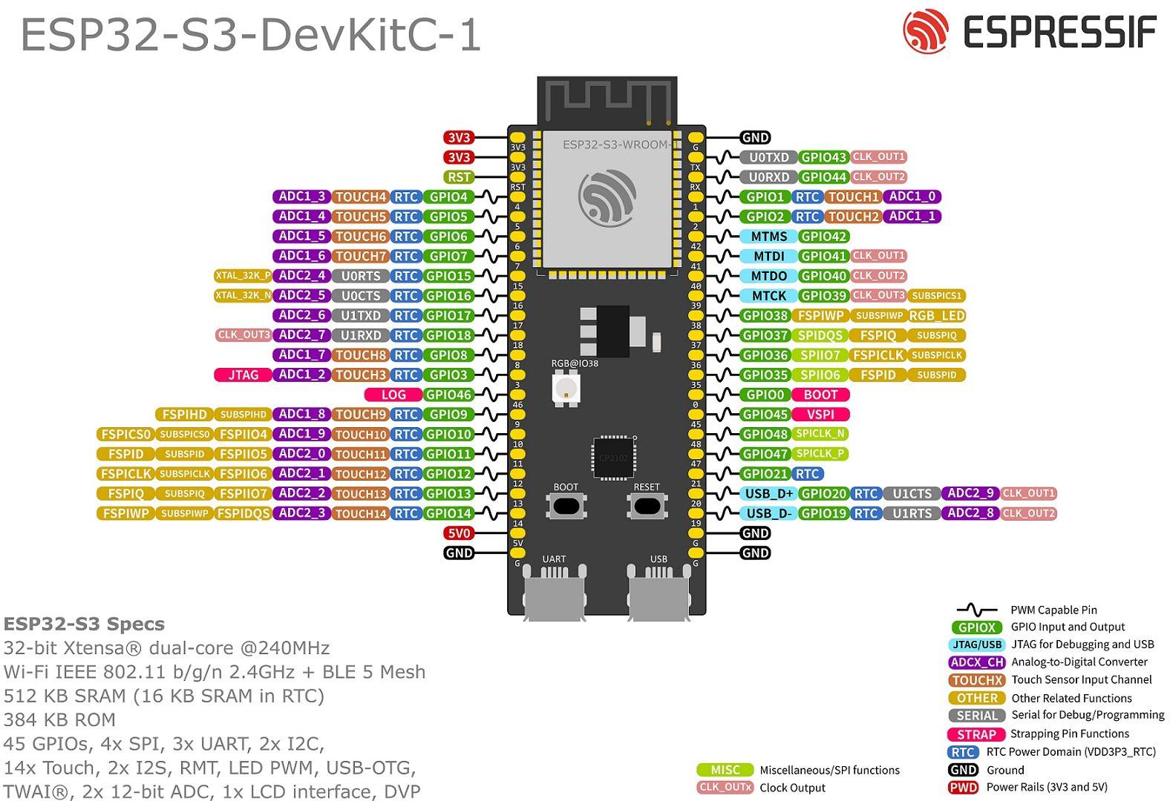

Figure 9 : ESP32 Hardware Components

We use ESP32-S3-WROOM-1-N16R8 Flash Memory 16 MB (Quad SPI) 8 MB PSRAM (Octal SPI) ESP32 function as a Webserver, WebSocket Server, and A main controller for Robot Car. The ESP32 controller is the heart of the system. beside controlling robot operation, ESP also communicates with clients to receive commands and send data to the client to display the robot's status.

Module Overview

Module Overview



https://[www.espressif.com/documentation/esp32-s3-wroom-1_wroom-1u_datasheet_en.pdf](http://www.espressif.com/documentation/esp32-s3-wroom-1_wroom-1u_datasheet_en.pdf)

Features

CPU and On-Chip Memory

* ESP32-S3 series of SoCs embedded, Xtensa® dual-core 32-bit LX7 microprocessor (with single precision FPU), up to 240 MHz
* 384 KB ROM
* 512 KB SRAM
* 16 KB SRAM in RTC
* Up to 16 MB PSRAM

Wi-Fi

* 802.11b/g/n
* Bit rate: 802.11n up to 150 Mbps
* A-MPDU and A-MSDU aggregation
* 0.4 *µ*s guard interval support
* Center frequency range of operating channel: 2412 ~ 2484 MHz

Bluetooth

* Bluetooth LE: Bluetooth 5, Bluetooth mesh
* Speed: 125 Kbps, 500 Kbps, 1 Mbps, 2 Mbps
* Advertising extensions
* Multiple advertisement sets
* Channel selection algorithm #2
* Internal co-existence mechanism between Wi-Fi and Bluetooth to share the same antenna

Peripherals

* 36 GPIOs

– 4 strapping GPIOs

* SPI, LCD interface, Camera interface, UART, I2C, I2S, remote control, pulse counter, LED PWM, full-speed USB 2.0 OTG, USB Serial/JTAG controller, MCPWM, SDIO host controller, GDMA, TWAI® controller (compatible with ISO 11898-1), ADC, touch sensor, temperature sensor, timers and watchdogs

Integrated Components on Module

* 40 MHz crystal oscillator
* Up to 16 MB Quad SPI flash

Antenna Options

* ESP32-S3-WROOM-1: On-board PCB antenna
* ESP32-S3-WROOM-1U: External antenna via a connector

Operating Conditions

* Operating voltage/Power supply: 3.0 ~ 3.6 V
* Operating ambient temperature:

– 65 °C version: –40 ~ 65 °C

– 85 °C version: –40 ~ 85 °C

– 105 °C version: –40 ~ 105 °C

Certification

* RF certification: See certificates
* Green certification: RoHS/REACH

Test

* HTOL/HTSL/uHAST/TCT/ESD

#### Raspberry PI 3B+

**Raspberry Pi 3 Model B+**

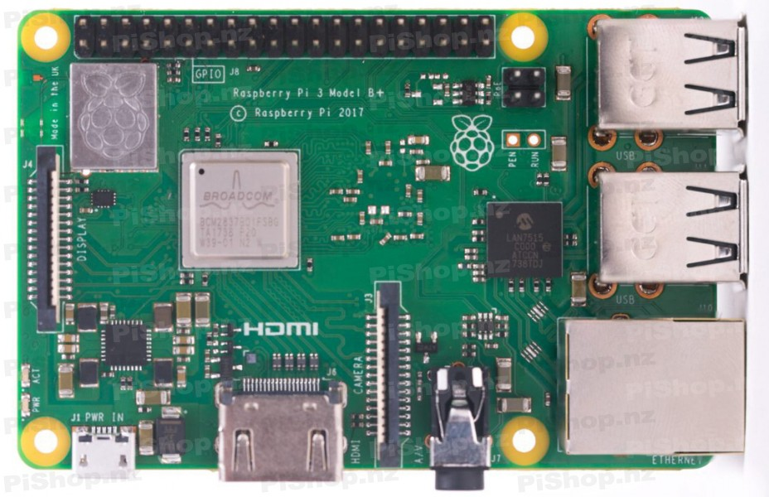

Figure 10: Raspberry PI 3 B+

|  |  |
| --- | --- |
| **Specification RPI 3B+** | |
| * Quad Core 1.2GHz Broadcom BCM2837 64bit CPU * BCM43438 wireless LAN and Bluetooth Low Energy (BLE) on board 100 Base Ethernet * 4 USB 2 ports * Full-size HDMI® * DSI display port for connecting a Raspberry Pi touchscreen display * Upgraded switched | * 1GB RAM * 40-pin extended GPIO * 4-Pole stereo output and composite video port * CSI camera port for connecting a Raspberry Pi camera * Micro SD port for loading your operating system and storing data * **Micro USB power source up to 2.5A** |

Table 2: Specification of RPI 3B+, Source: [https://www.raspberrypi.com/products/raspberry-pi-3-model-b/](http://www.raspberrypi.com/products/raspberry-pi-3-model-b/)

#### Raspberry PI 5

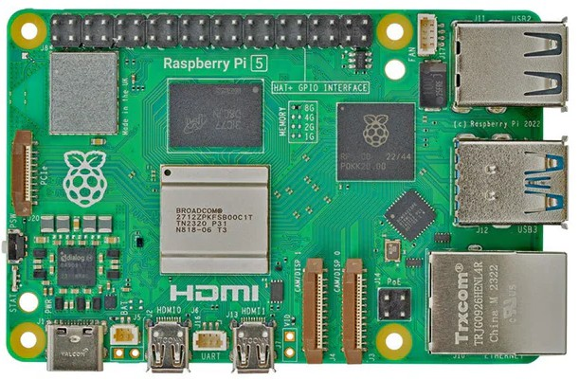

Figure 11: Raspberry PI 5

|  |  |
| --- | --- |
| **Specification RPI 5** | |
| * SoC Broadcom BCM2712 * Clock speed 4x 2.4 GHz * RAM 8 GB LPDDR4X (4267 MHz) * Bluetooth 5.0, BLE * USB 2x USB-A 3.0 (5 GBit/s) * PCI Express 1x PCIe 2.0 * Video 2x micro-HDMI ports (4K60) * Multimedia H.265 (4K60 decode) * SD card microSD | * CPU ARM Cortex-A76 (ARM v8) 64-bit * GPU VideoCore VII (800 MHz) * WiFi IEEE 802.11b/g/n/ac (2.4 GHz/5 GHz) * Ethernet Gigabit Ethernet (with PoE+ support) * 2x USB-A 2.0 * GPIO Standard 40-pin GPIO header * 2x 4-lane MIPI (DSI/CSI) * OpenGL ES 3.1, Vulkan 1.2   **-Power 5 V/5 A (via USB-C)**   * Power over Ethernet (PoE+) |

Table 3: Specification of RPI 5, Source: [https://www.raspberrypi.com/products/raspberry-pi-5/](http://www.raspberrypi.com/products/raspberry-pi-5/)

In this project, RPI is used as a MQTT broker, a web server only, so we decided to use RPI 3B+ because the power requirement is only 5V, 2.5A.

#### RPLidar C1 [10]

The RPLIDAR C1 has a ranging radius of up to 12m, with a ranging blind zone as low as 0.05m, making it capable of easily scanning and ranging objects at various distances, addressing challenges posed by multiple environmental obstacles. It is suitable for practical applications such as robotic vacuum cleaners, educational ROS (Robot Operating System) cars, commercial robots, low-speed unmanned vehicles in parks, and parking space detection. The typical scanning frequency of the RPLIDAR C1 is 10Hz (600rpm). At this frequency, a sampling rate of 5,000 can achieve an angular resolution of 0.72°. The RPLIDAR C1 integrates years of technical expertise in triangulation and Time-of-Flight (TOF) ranging, providing depth fusion. It meets the requirements for robot positioning, mapping, and navigation and offers performance in ranging accuracy, distance measurement, anti-interference, and anti-tailing. The RPLIDAR C1 consists of a laser-ranging core and the power supply and mechanical components responsible for the high-speed rotation of the laser-ranging core. During normal operation, the ranging core starts rotating clockwise for scanning. Users can obtain the scanning ranging data of the RPLIDAR C1 through its communication interfaces, such as serial port or USB.

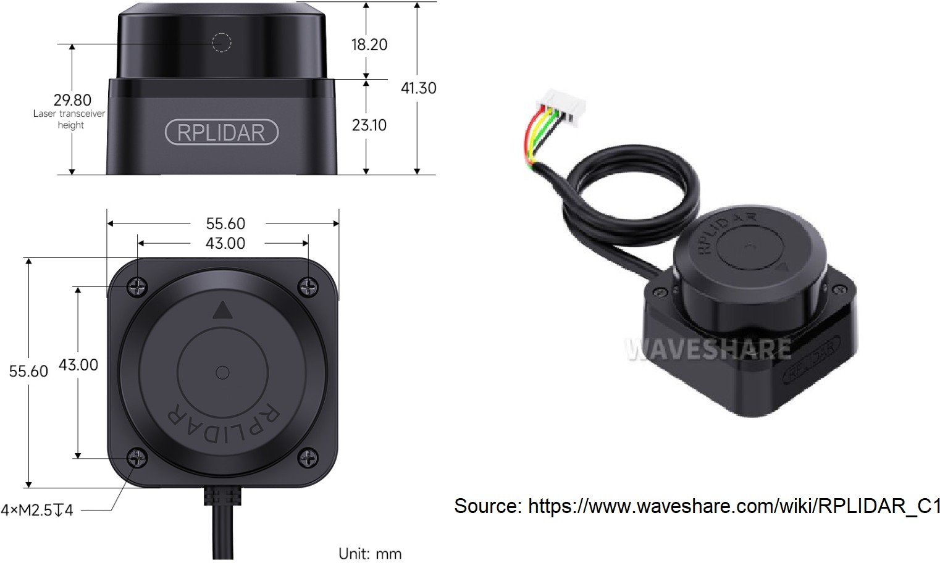

Figure 12: RPlidar C1 (source <https://www.waveshare.com/wiki/RPLIDAR_C1>)

#### Specification

Next-generation integrated ranging technology Supports UART communication UART @ 460800bps

Measurement radius of 0.05 12.00m (white target, 70% reflectivity); 0.05 6.00m (black target, 10% reflectivity)

Measurement frequency of 5000Hz 360° scanning range

Laser safety compliant with Class 1 standards **Working Mode** The standard configuration of RPLIDAR C1 utilizes a 3.3V level serial port (UART) as the communication interface and can, based on customer requirements, adopt other interfaces such as USB. The table below provides specifications based on the serial interface:

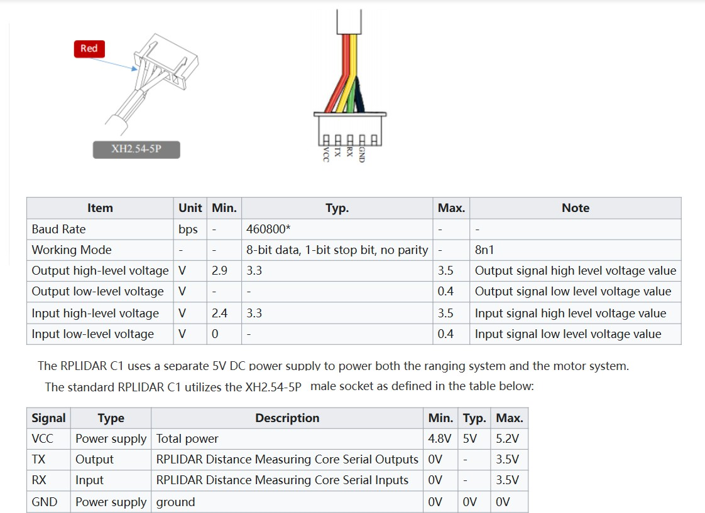

Figure 13: Working Mode for RPlidar C1 <(https://www.waveshare.com/wiki/RPLIDAC1)>

#### Intel Realsens Depth Camera [11]

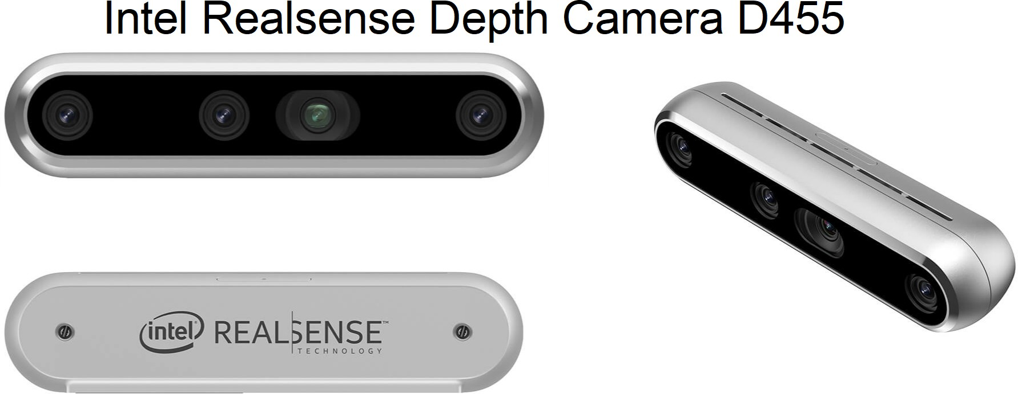

Figure 14: Intel Realsense depth camera D455 [(https://www.intelrealsense.com/depth-camera-d455/)](http://www.intelrealsense.com/depth-camera-d455/))

The Intel® RealSense™ Depth Camera D455 (Manufacturer’s Part 999WCR is a USB-powered camera

that includes wider field of view depth sensors and an RGB sensor. The D455 extends the distance between the depth sensors to 95 mm, which improves the depth (Z) error* to less than 2% at 4 m.

The wider baseline provides better accuracy at the same range of the D415/D435/D435i. To improve the RGB image and the correspondence between the depth and RGB images, the RGB sensor includes a global shutter and is matched to the depth FOV, with both having an 86° field of view.

The D455 uses the open-source Intel RealSense™ SDK 2.0, making it easy to switch from previous RealSense cameras to the D455.

#### Specification:

Intel® RealSense™ Depth Camera D455 Intel®RealSense™ Vision Processor D4

up to 1280 x 720 active stereo depth resolution up to 1280 x 800 RGB resolution

diagonal field of view over 90°

Two global shutter sensors for depth streaming at up to 90 frames/s RGB global shutter sensor for up to 90 frames/s

Range 0.4 m to over 10 m (varies depending on lighting conditions)

Includes Inertial Measurement Unit (IMU) for 6 degrees of freedom (6DoF)

#### DC Motor Driver BTS7960 [12]

The BTS7960 is a fully integrated high-current H-bridge module for motor drive applications. Interfacing to a microcontroller is made easy by the integrated driver IC, which features logic-level inputs, diagnosis with current sense, slew rate adjustment, dead time generation, and protection against overtemperature, overvoltage, undervoltage, overcurrent, and short circuit. The BTS7960 provides a cost-optimized solution for protected high-current PWM motor drives with very low board space consumption.

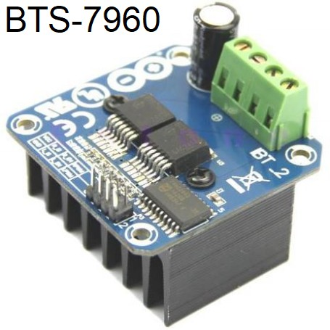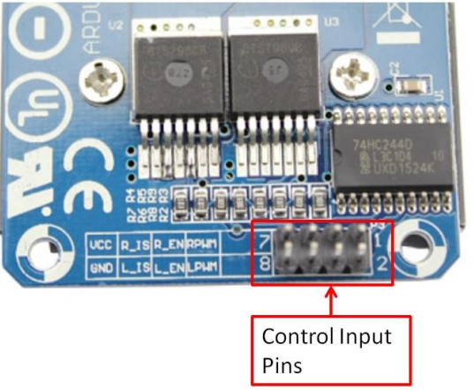

Figure 15: DC motor driver BTS-7960

|  |  |
| --- | --- |
| **Specification BST-7960** | |
| * Input Voltage: 6 27Vdc. * Driver: Dual BTS7960 H Bridge Configuration. * Peak current: 43-Amp. * PWM capability of up to 25 kHz. * Control Input Level:   3.3 5V. | * Control Mode: PWM or level * Working Duty Cycle: 0 100 * Over-voltage Lock Out. * Under-voltage Shut Down. * Board Size (LxWxH): 50mm x 50mm x 43mm. * Weight: 66g. |

Table 4: DC Motor Controller BST-7960 Specification **Control Input Pin Function:**

|  |  |  |
| --- | --- | --- |
| Pin No | Function | Description |
| 1 | RPWM | Forward Level or PWM signal, Active High |
| 2 | LPWM | Reverse Level or PWM signal, Active High |
| 3 | R_EN | Forward Drive Enable Input, Active High/ Low Disable |
| 4 | L_EN | Reverse Drive Enable Input, Active High/Low Disable |
| 5 | R_IS | Forward Drive, Side current alarm output |
| 6 | L_IS | Reverse Drive, Side current alarm output |
| 7 | Vcc | +5V Power Supply microcontroller |
| 8 | Gnd | Ground Power Supply microcontroller |

Table 5: Control Input Pin BTS-7960

#### Motor Power Supply and Output Pin:

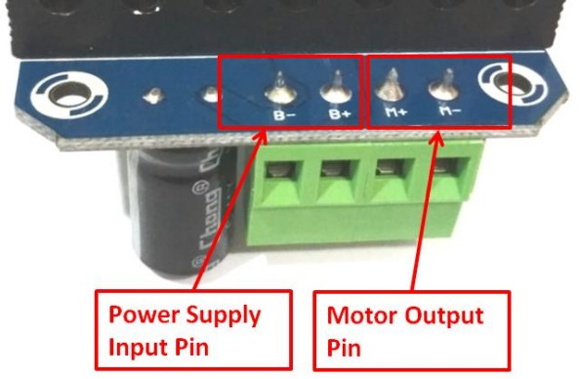

Figure 16: Motor driver BTS-7960 power supply and motor pin

|  |  |  |
| --- | --- | --- |
| Pin No | Function | Description |
| 1 | B+ | Positive Motor Power Supply. 6 27VDC |
| 2 | B- | Negative Motor Power Supply. Ground |
| 3 | M+ | Motor Output + |
| 4 | M- | Motor Output - |

Table 6: Motor Pin and power supply for BST-7960

#### PS2 Remote 2.4Ghz and receiver [14]

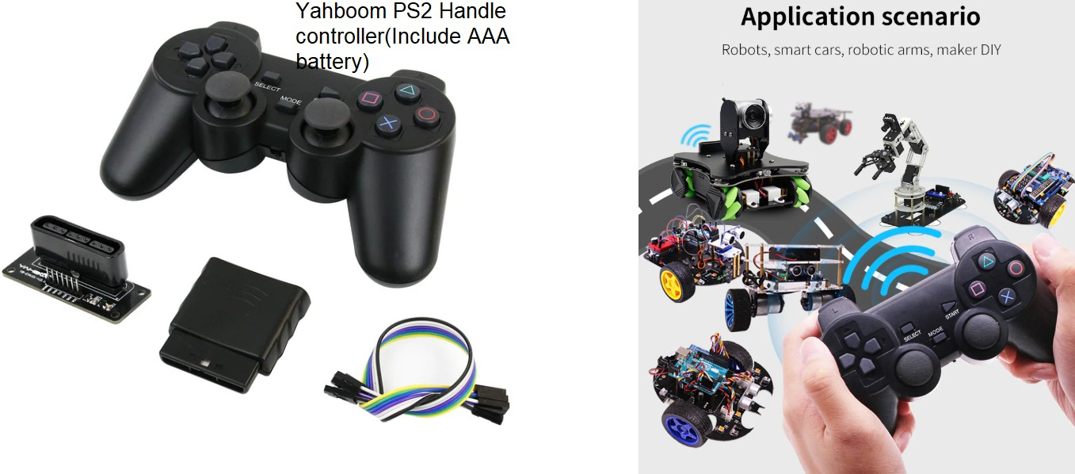Introduction of PS2 controller and MCU communication: The PS2 consists of two parts: the handle and the receiver. The handle is mainly responsible for sending key information. When the power is turned on and the handle switch is turned on, the handle and the receiver are automatically paired. When the pairing is not successful, the green light of the receiver flashes, and the light on the handle also flashes. After the pairing is successful, the green light on the receiver is on. the light on the handle is also light on. The users can press the “MODE” button to select the handle transmission mode. Red light mode: analog output value of the joystick; Green light mode: The remote lever corresponds to the above four buttons, and only four extreme directions correspond. The receiver is connected to the host (single-chip microcomputer) to realize communication between the host and the handle.

Figure 17: Yahboom PS2 Remote ( https://category.yahboom.net/products/yahboom-ps2-handle-controller)

#### Lora 433Mhz SX-1278 [15]

The SX1278 is a widely used LoRa transceiver known for its long-range communication capabilities, especially in the sub-1 GHz frequency range. It is part of the previous generation of LoRa modules and remains popular for long-range IoT communication projects.

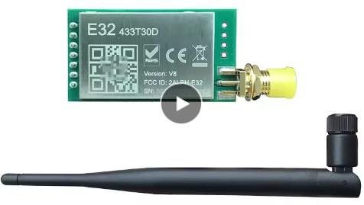

Figure 18: Lora SX-1278 [Ebyte(https://www.cdebyte.com/news/580)](http://www.cdebyte.com/news/580))

LoRa SX1278 SX1276 rf Transmitter and Receiver Module E32-TTL-1W UART 433MHz 1W Long Range 8KM Wireless Transceiver for the Arduino

Parameter:

|  |  |
| --- | --- |
| **Specification SX-1278 LORA 433Mhz** | |
| Frequency R | 10.3 mA (standby), 14 mA (Rx, LoRa) |
| Transmitter Current range | 433 MHz, 868 MHz, 915 MHz |
| Modulation Schemes | LoRa, FSK, GFSK, MSK, GMSK |
| Spreading Factors | 6 to 12 (configurable) |
| Output Power | Up to +20 dBm |
| Sensitivity (LoRa) | Down to -139 dBm |
| Receiver Current | 10.3 mA (standby), 14 mA (Rx, LoRa) |
| Transmitter Current | 120 mA (Tx, +20 dBm) |
| Sleep Current | 0.2 µA |
| Operating Temperature | -40°C +85°C |
| Interfaces | SPI, I2C, UART |

Table 7: Specification of LORA SX-1278 Ebyte manufacture

#### IoT Spectrum in New Zealand [16]

IOT Spectrum license in New Zealand:

When it comes to the spectrum to support M2M and IoT applications in New Zealand, a mix of licensing arrangements and a variety of frequency bands may be required to support different IoT use cases.

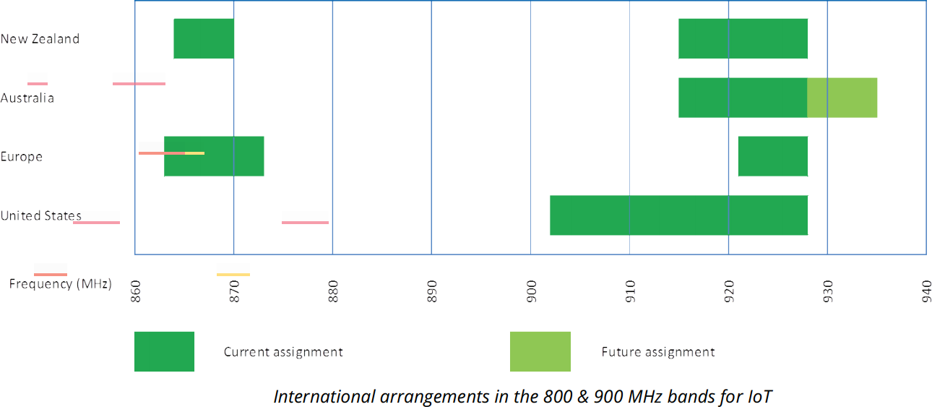In New Zealand, there are two blocks of general user spectrum that, to date (2019), have shown the most deployment for IoT connectivity outside of the WiFi bands (being 2.4 and 5 GHz). These bands are the **868 and 900 MHz bands**, respectively. Figure 5 shows the comparison of international arrangements between various countries.

Figure 19: IOT Spectrum requirement in New Zealand

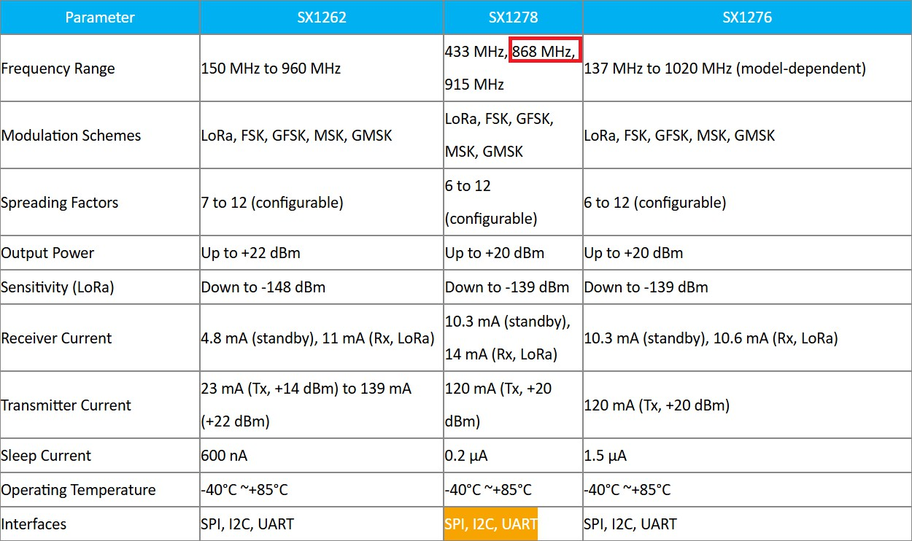

Table 8: Lora frequency range [SX-xxxx(https://www.cdebyte.com/news/580)](http://www.cdebyte.com/news/580))

According to the New Zealand spectrum requirement, We can only use LORA which have frequency range about 860Mhz to 870 Mhz

### Software Components

#### Arduino IDE [17]

* + - * Arduino IDE is an open-source software designed by Arduino.cc and mainly used for writing, compiling & uploading code to almost all Arduino Modules.
        + It is an official Arduino software, making code compilation so easy that even a common person with no prior technical knowledge can get their feet wet with the learning process.
        + It is available for all operating systems, i.e., MAC, Windows, Linux, and runs on the Java Platform that comes with inbuilt functions and commands that play a vital role in debugging, editing, and compiling the code.
        + A range of Arduino modules available, including Arduino Uno, Arduino Mega, Arduino Leonardo, Arduino Micro, and many more. • Each of them contains a microcontroller on the board that is actually programmed and accepts the information in the form of code.
        + The main code, also known as a sketch, created on the IDE platform will ultimately generate a Hex File, which is then transferred and uploaded in the controller on the board.
        + The IDE environment mainly contains two basic parts: Editor and Compiler, where the former is used for writing the required code and the latter is used for compiling and uploading the code into the given Arduino Module.
        + This environment supports both C and C++ languages.

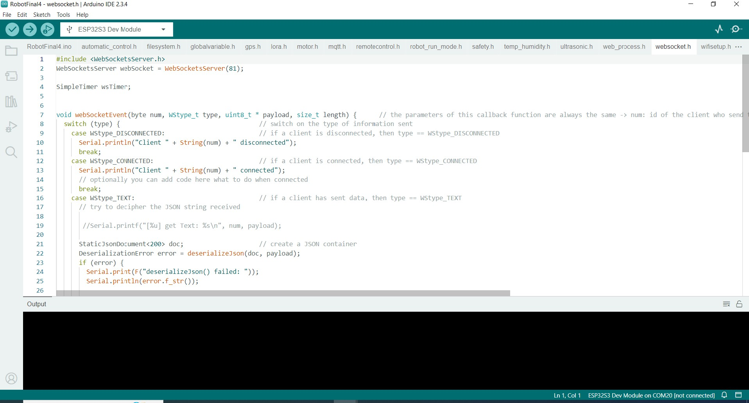

Figure 20: Screenshot of Arduino IDE software

#### Python [18]

Python is a high-level, general-purpose programming language. Its design philosophy emphasizes code readability with the use of significant indentation.

Python is dynamically type-checked and garbage-collected. It supports multiple programming paradigms, including structured (particularly procedural), object-oriented, and functional programming. It is often described as a "batteries included" language due to its comprehensive standard library.

Guido van Rossum began working on Python in the late 1980s as a successor to the ABC programming language and first released it in 1991 as Python 0.9.0. Python 2.0 was released in 2000. Python 3.0, released in 2008, was a major revision not completely backward-compatible with earlier versions. Python 2.7.18, released in 2020, was the last release of Python 2.

Python consistently ranks as one of the most popular programming languages and has gained widespread use in the machine learning community.

In this robot car project, we use Python language as a Flask web server and image recognition YOLOv10 to detect objects and read distance from object to robot car by using Intel Realsens Camera.

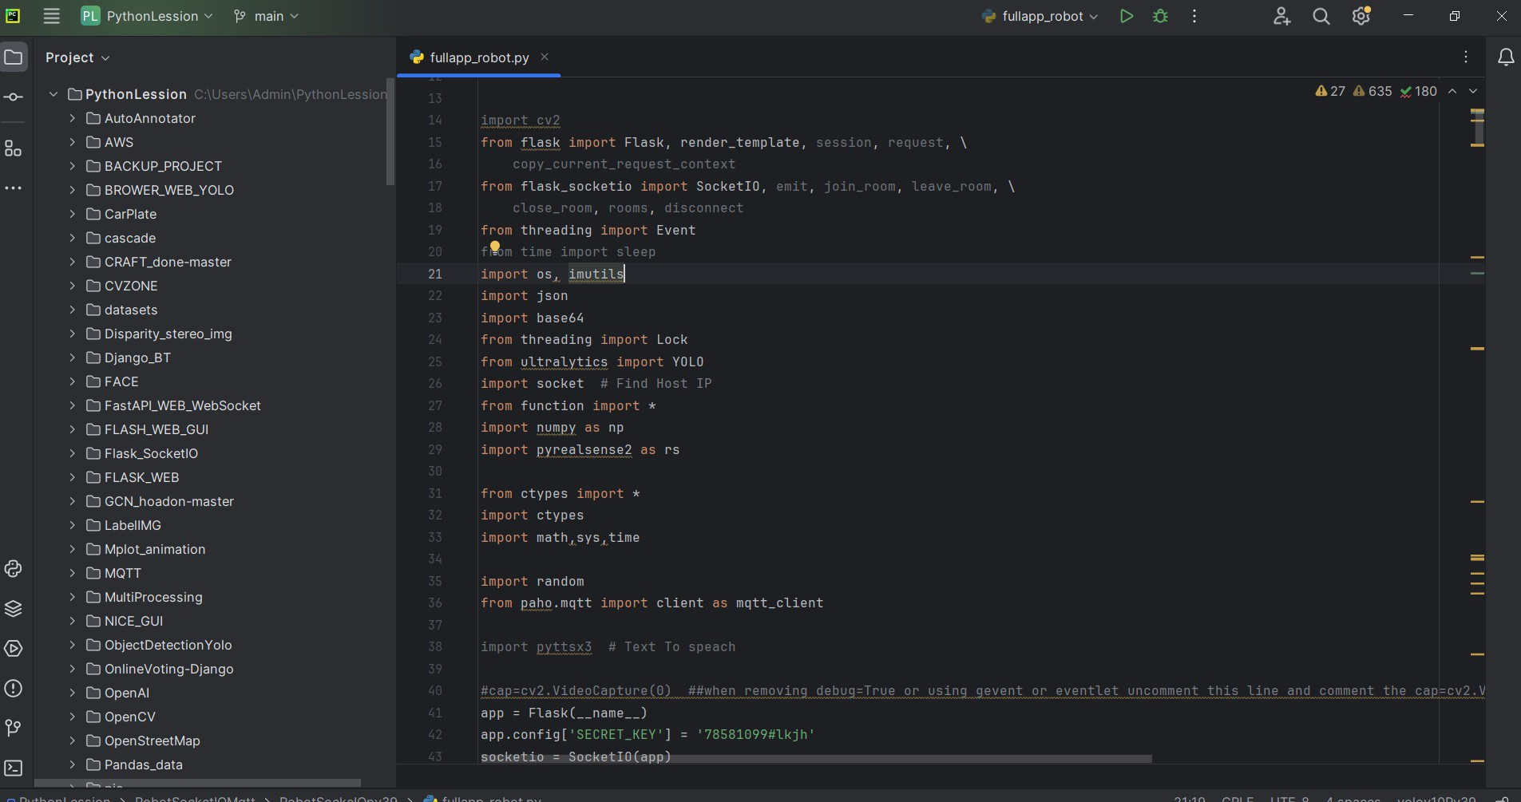

Figure 21: Screenshot of Pycharm for programming Python

#### Visual Studio Code, HTML Javascript and PHP [19]

Visual Studio Code, commonly referred to as VS Code, is a source code editor developed by Microsoft for Windows, Linux, macOS, and web browsers. Features include support for debugging, syntax highlighting, intelligent code completion, snippets, code refactoring, and embedded version control with Git. Users can change the theme, keyboard shortcuts, and preferences, install extensions that add functionality, and set up VS Code to use as IDE.

Visual Studio Code is proprietary software released under the "Microsoft Software License" but based on the MIT-licensed program named "Visual Studio Code — Open Source" (also known as "Code — OSS"), also created by Microsoft and available through GitHub.

In the 2024 Stack Overflow Developer Survey, out of 58,121 responses, 73.6% of respondents reported using Visual Studio Code, more than twice the percentage of respondents who reported using its nearest text editor and/or IDE alternative, Visual Studio.

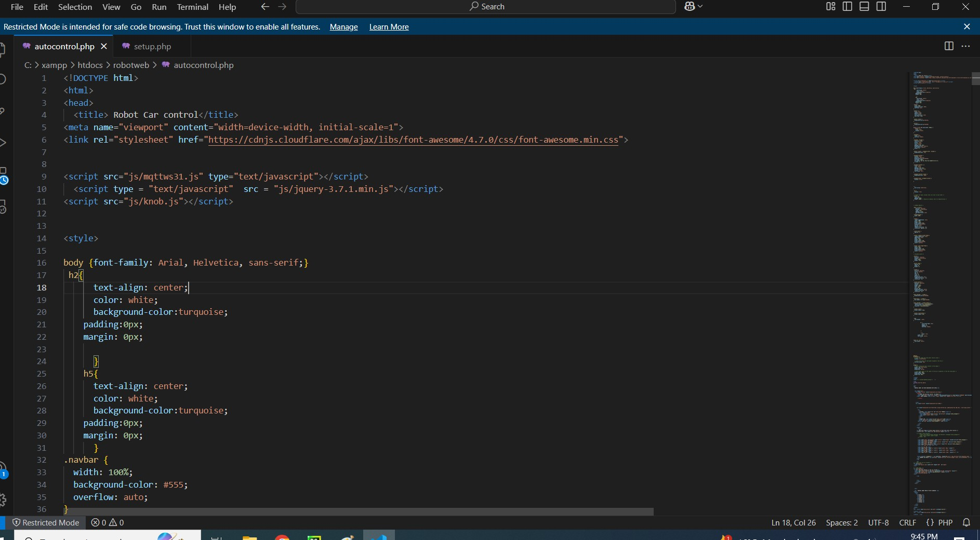

Figure 22: Screenshot of Visual studio code

#### MIT APP [20]

MIT App Inventor is an intuitive, visual programming environment that allows everyone, even children, to build fully functional apps for smartphones and tablets. Those new to MIT App Inventor can have a simple first app up and running in less than 30 minutes. What’s more, our blocks-based tool facilitates the creation of complex, high-impact apps in significantly less time than traditional programming environments. The MIT App Inventor project seeks to democratize software development by empowering all people, especially young people, to move from technology consumption to technology creation.

A small team of CSAIL staff and students, led by Professor Hal Abelson, forms the nucleus of an international movement of inventors. In addition to leading educational outreach around MIT App Inventor and researching its impacts, this core team maintains the free online app development environment that serves more than 6 million registered users.

Blocks-based coding programs inspire intellectual and creative empowerment. MIT App Inventor goes beyond this to provide real empowerment for kids to make a difference – a way to achieve a social impact of immeasurable value to their communities

In this project, we use the MIT app to create an application to control a car using the MQTT communication protocol. The MIT App is one of the best applications for programming Android applications. It is very easy to use, especially for anyone who has never used Java to program Android. This application is easily used with a cloud-based platform, so we can use it anywhere.

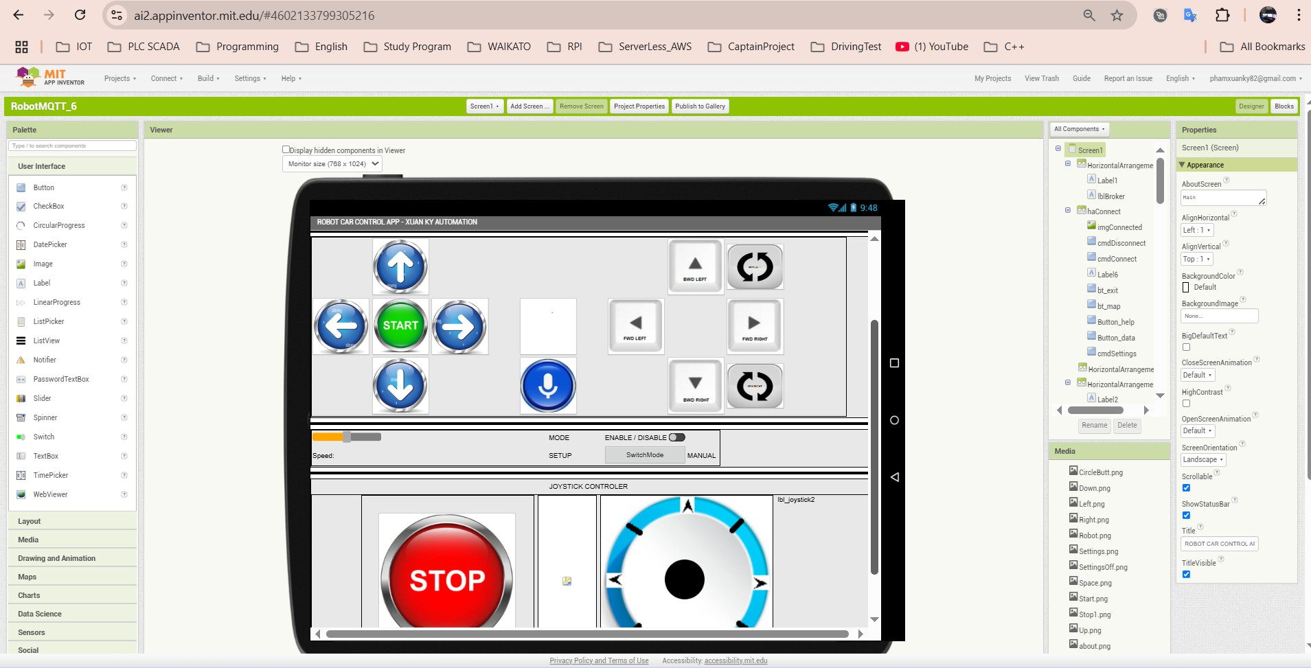

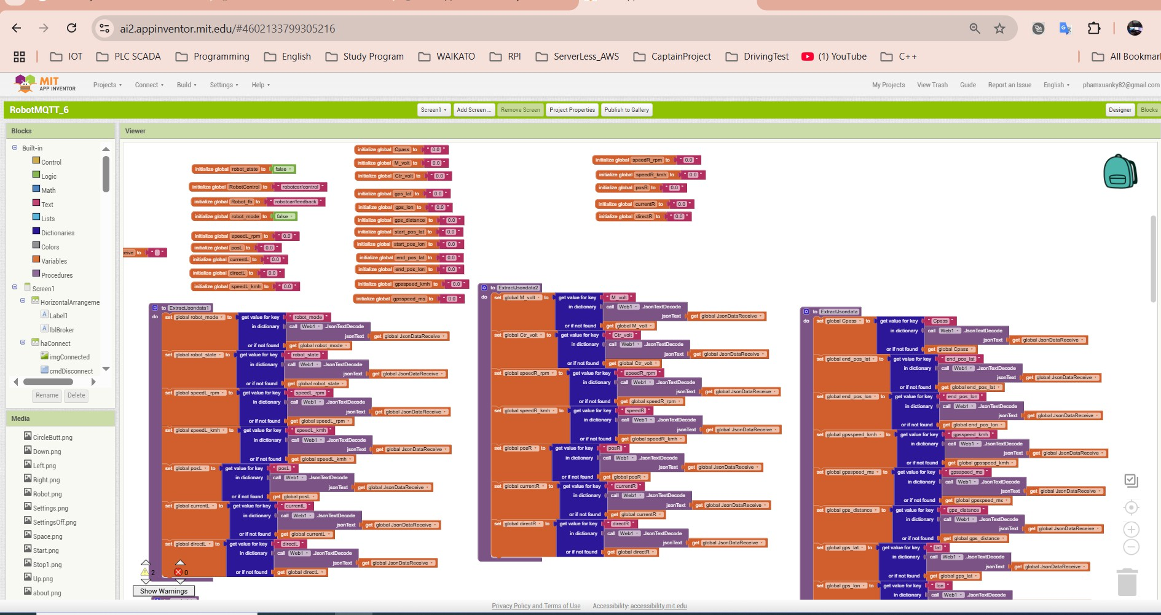

Figure 23: Screenshot of Robot Car Android MIT Application

### Architecture and Schematics

#### 3.3.1 ROBOT CAR Architecture

#### The figure below indicates the Architecture design for a robot car in 2025. The main controller is ESP32, however, Raspberry PI and PC also play important roles in making this Automatic car more professional than the previous version, such as IoT MQTT, Image processing, and a Webserver in this project.

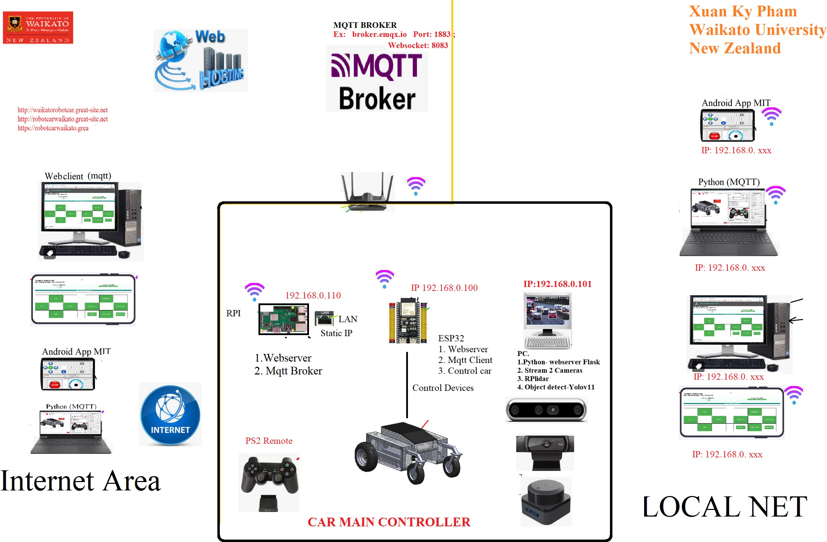

Figure 24: Architect diagram for robot car

#### 3.3.2 ROBOT CAR Schematic

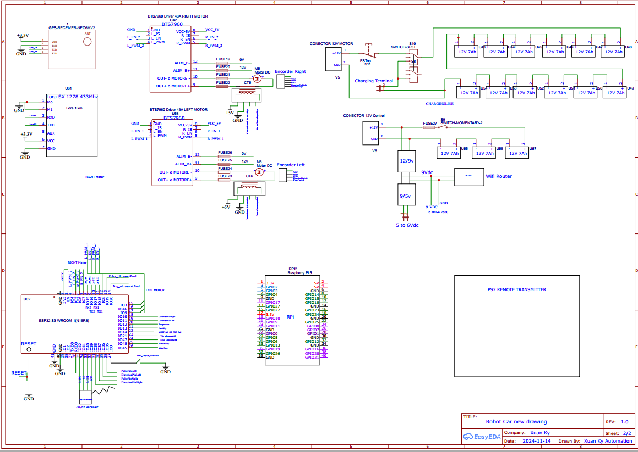

Figure 25: Schematic diagram for robot

### Networking and IoT Integration

What is a Web Server?

A web server is a software application that serves web pages to users. When a user requests a web page, the web server processes the request and sends the requested page back to the user’s browser. This forms the backbone of data communication on the World Wide Web.

Webpage PHP for Webserver Raspberry PI, Websever Hosting on Internet.

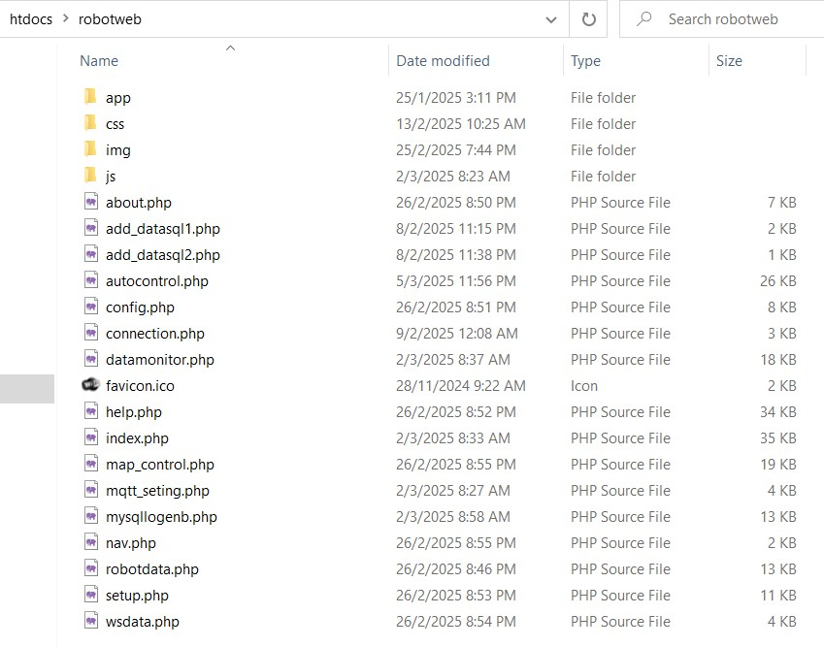

Figure 26: Webpage for Python Flask Application in PC HTML and Javascript

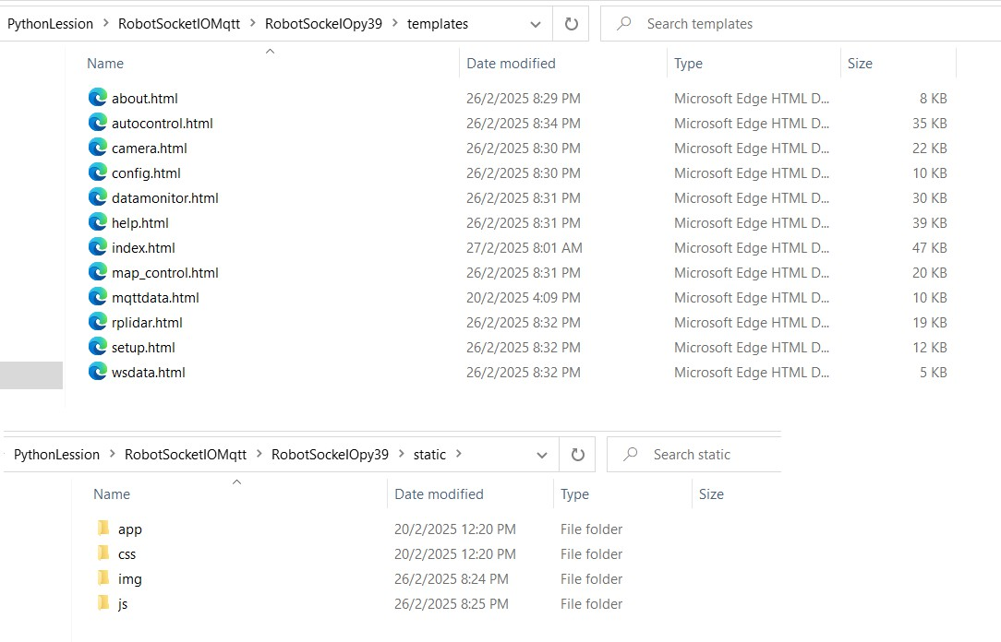

Figure 27: Webpage for ESP32 HTML Javascript

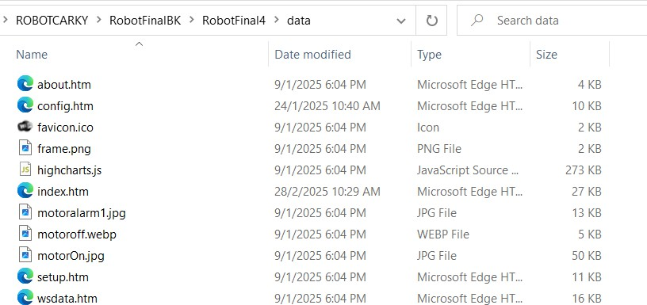

Figure 28: Web pages for ESP32

#### WebServer on ESP32

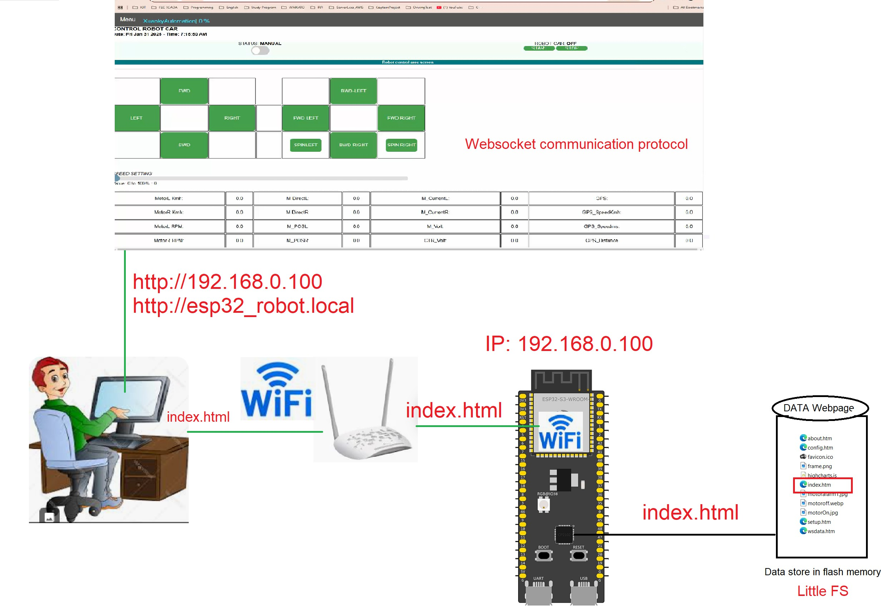In this project, we use LittleFS to store web pages in ESP32. When the user requests a webpage, ESP32 will send this web page stored in the file system manager to the browser. In the webpage, two types of communications WebSocket and AJAX are used to transfer information from or to the web user to equipment. For example, if the user wants to control the start and stop of the robot car, the user can only access the webpage from ESP32 and click Start. This command will be sent to ESP32 by WebSocket protocol, and ESP32 will send this command to the Motor to operate the robot car.

Figure 29: ESP32 Webserver on file system flash memory

Secondly, when web pages are stored inside program memory, the web access speed will be faster. However, users cannot update a website without downloading a complete program. This kind of configuration has the advantage that the website's response time is faster, but it is very complicated to update a web page.

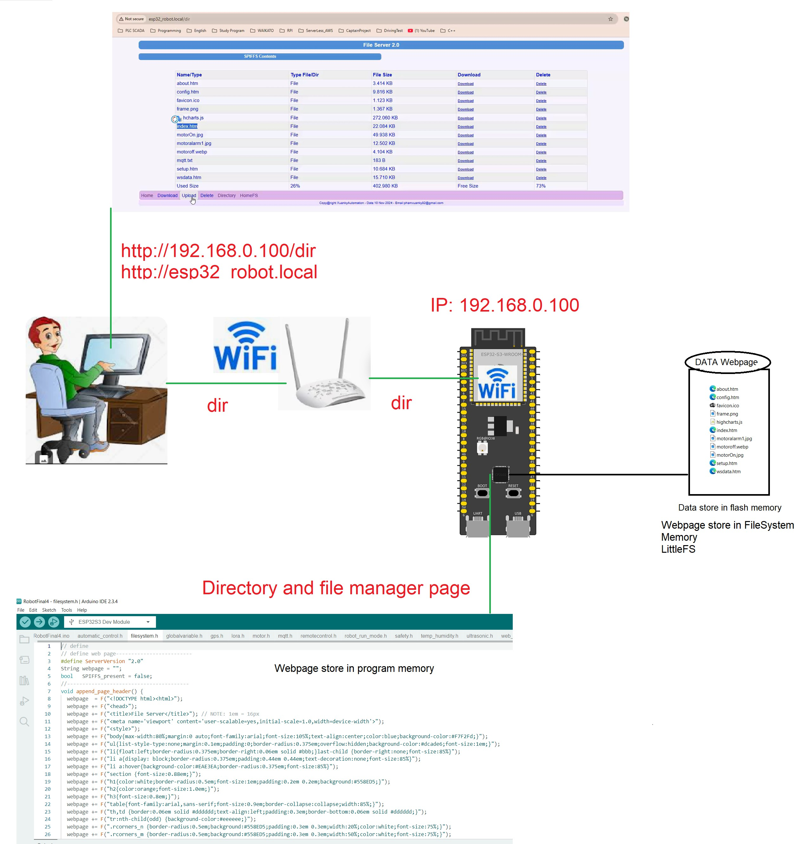

Figure 30: ESP32 Webserver stored in program memory

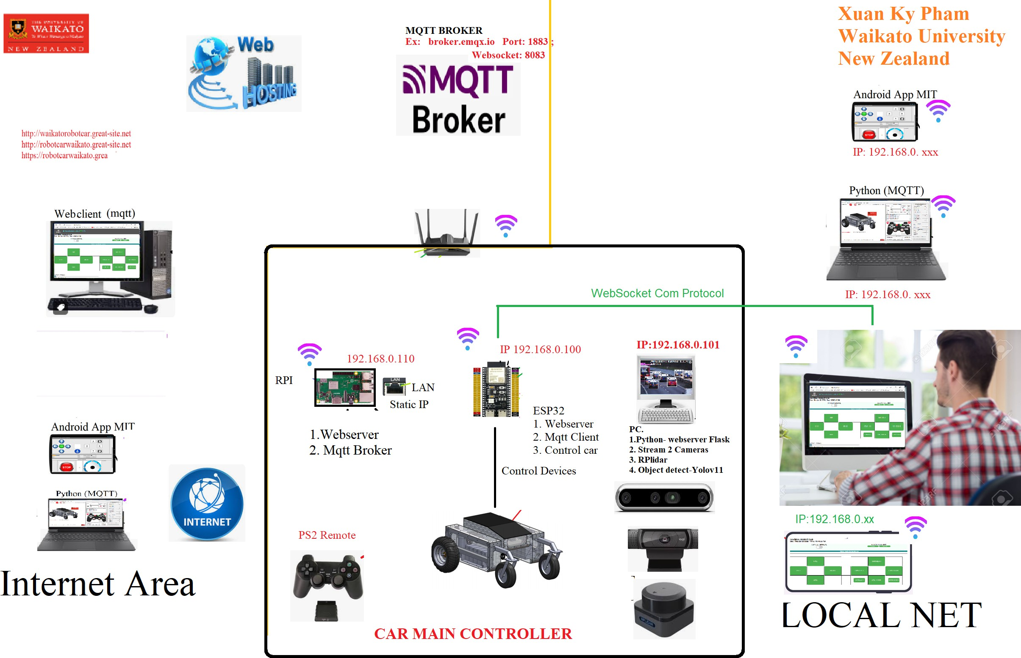

Figure 31: Accessing Webserver on ESP32 Robot Car

#### Webserver on RPI

**When the users operate the robot car by accessing the web page from RPI, the web page from RPI will be sent to the web browser. A robot car can be operated by two types of communication MQTT and WebSocket implemented in this web page**

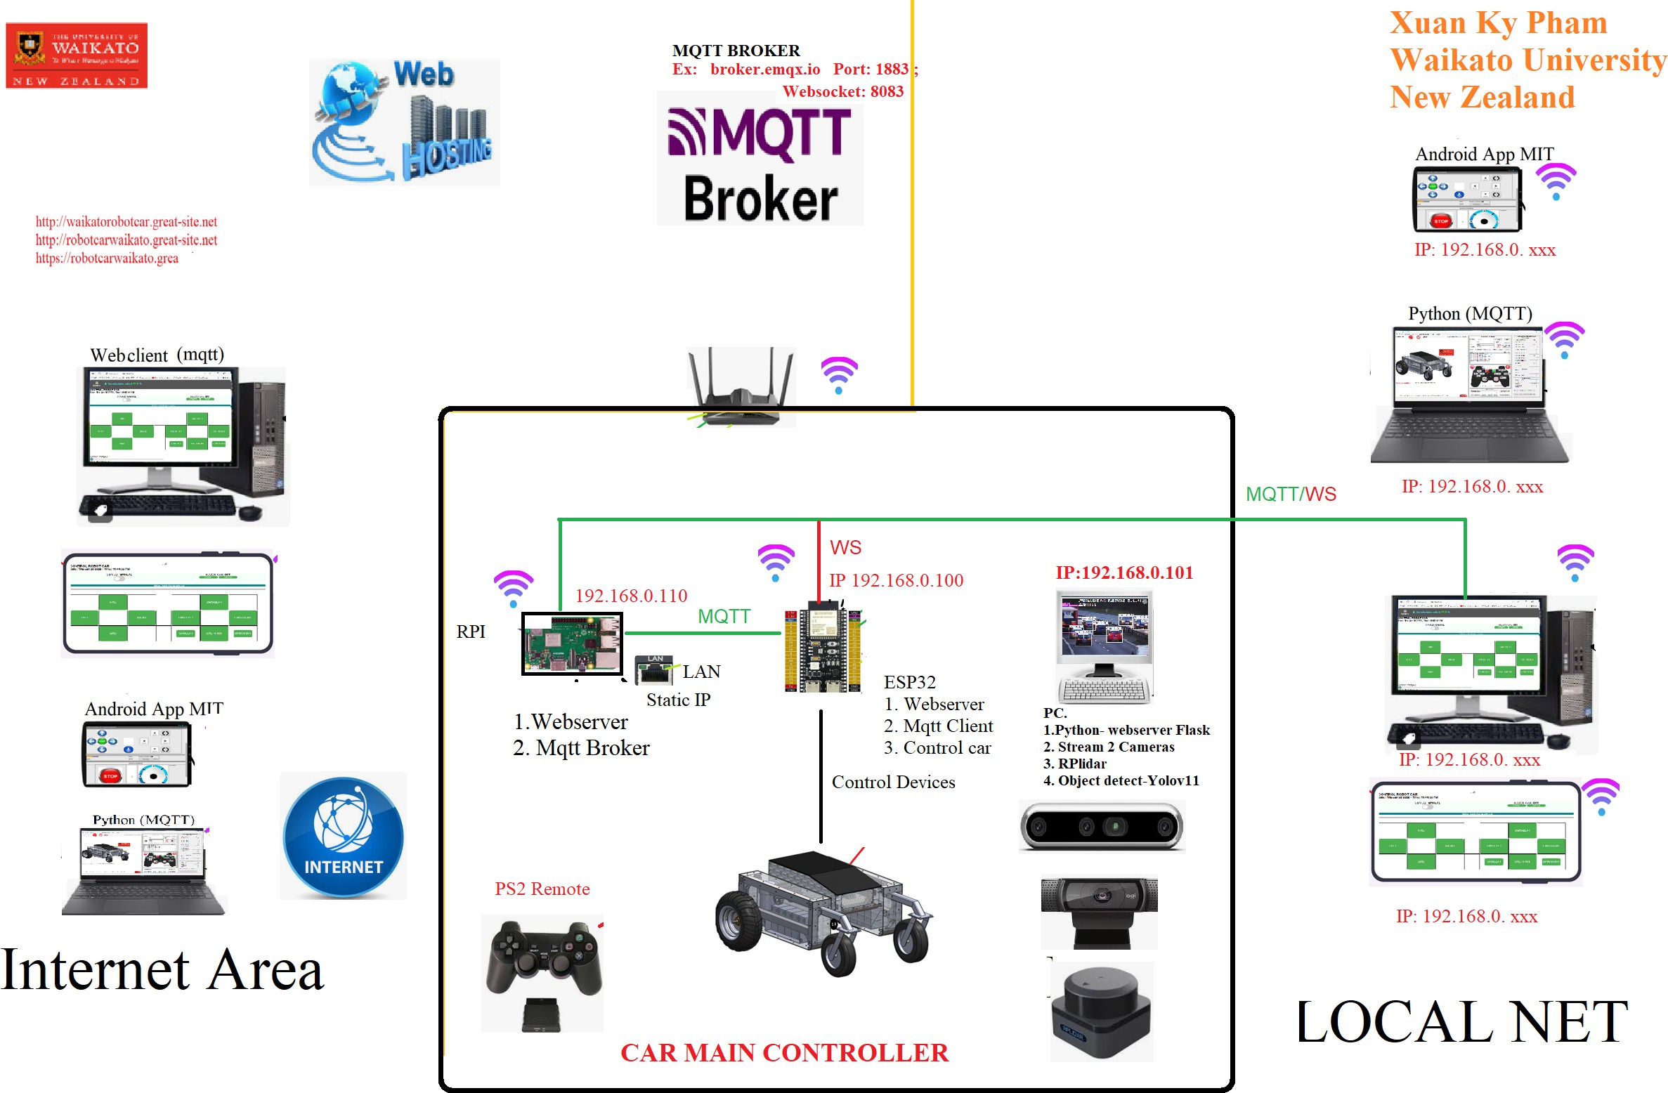

Figure 32: Accessing Webserver on RPI on ROBOT Car

#### Webserver on PC

On the local PC of Robot Car, we use the Python Flask web framework, HTML, and Javascript to create a web server. To run a web server, we need to run a Python script to start the server. This web server is created by Python, so we attached image processing with object recognition YOLO V10 and RPlidar. Python can do a good job in image processing, so we decided to use the Flask web framework on a local PC. Two webcams are installed on the local PC. One is a depth camera, an Intel real-sense camera. This camera can provide the depth matrix of an image so that we can estimate the distance from the robot car to objects, which is recognized by YOLO V10. Another normal webcam is used to stream the camera’s front video over a local network or the internet for visualization. Users can stream video from robot cars over a local network or the Internet with special configurations.



Figure 33: Webserver at Local PC of ROBOT Car

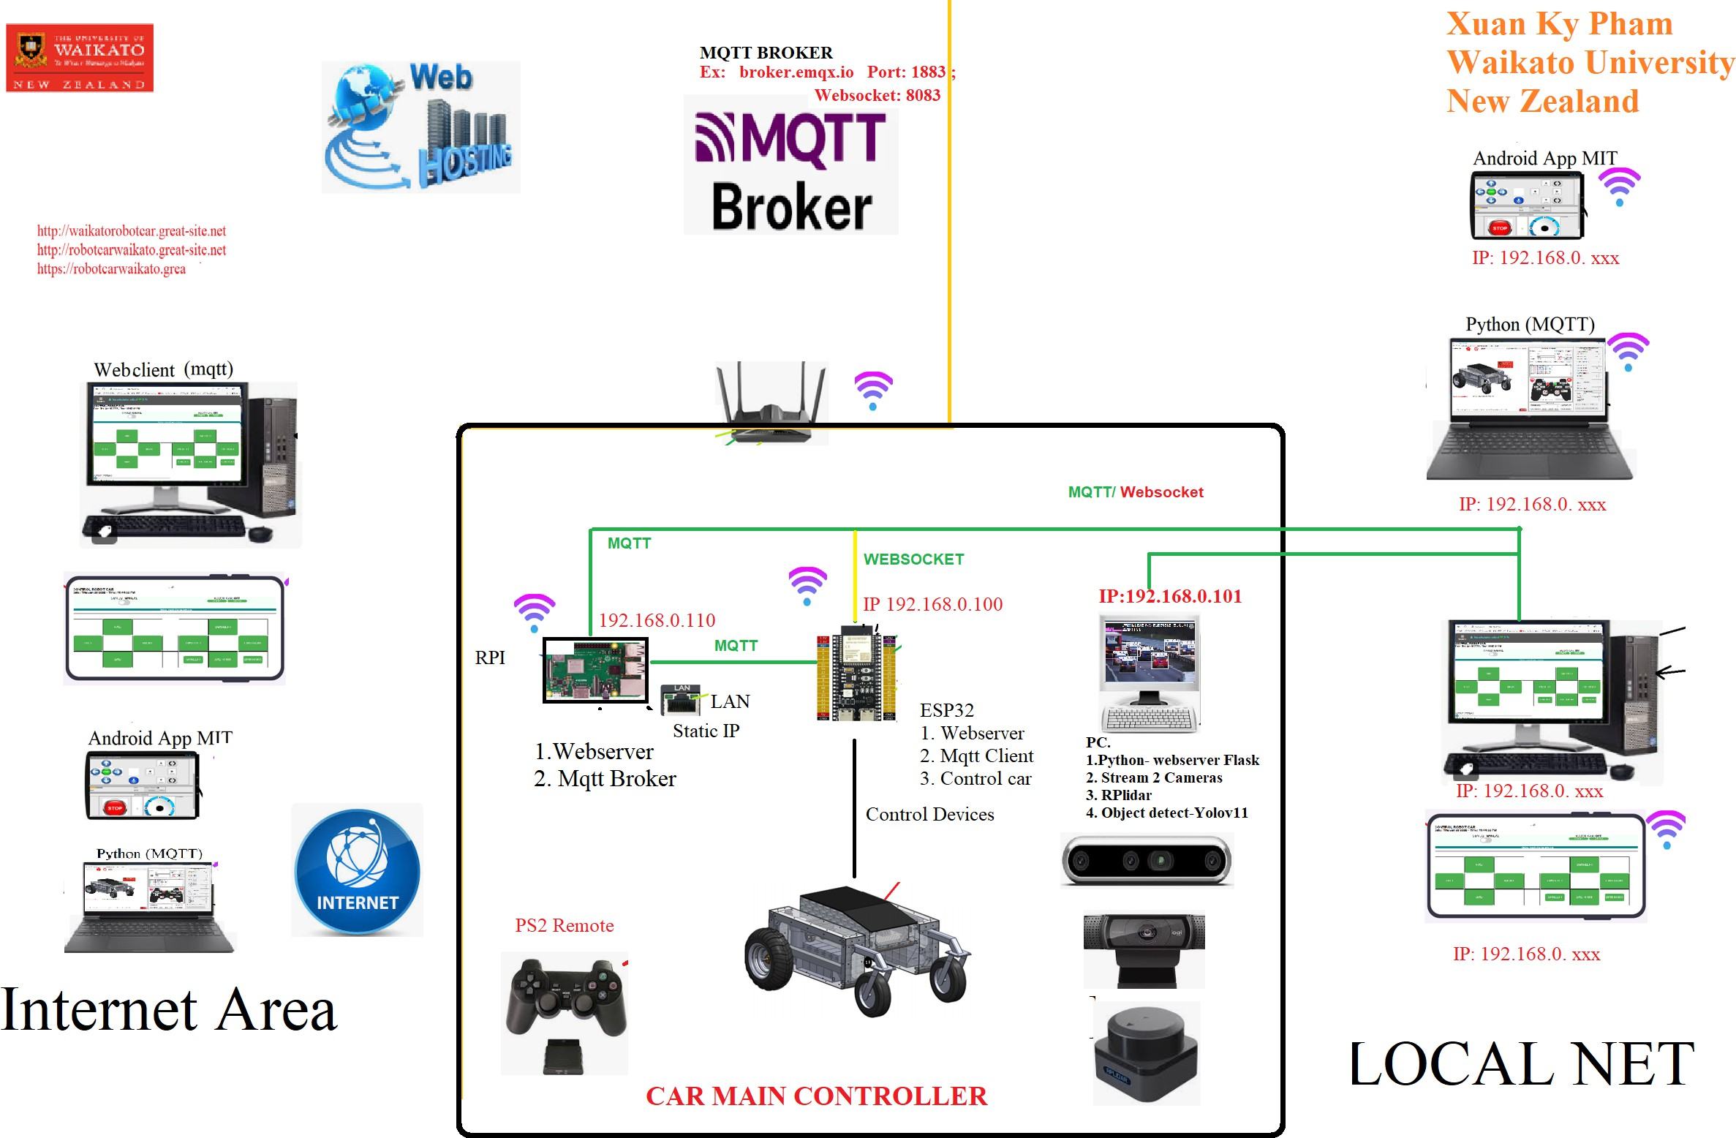

Figure 34: Accessing Flask Webserver at Local PC of ROBOT Car

#### Webserver on Internet

When users access the web server on the Internet, web hosting is where they store web pages. The MQTT protocol is used to communicate from the client web browser to the ESP32 robot car controller, as shown in the picture below. command to operate the robot sent from the client will be read by the ESP32 controller and transfer these actions to the robot car motor to travel or stop. Moreover, the data from the robot car, such as motor speed and current, will be returned to client web browsers. Users can easily monitor the robot car’s status.

jmm

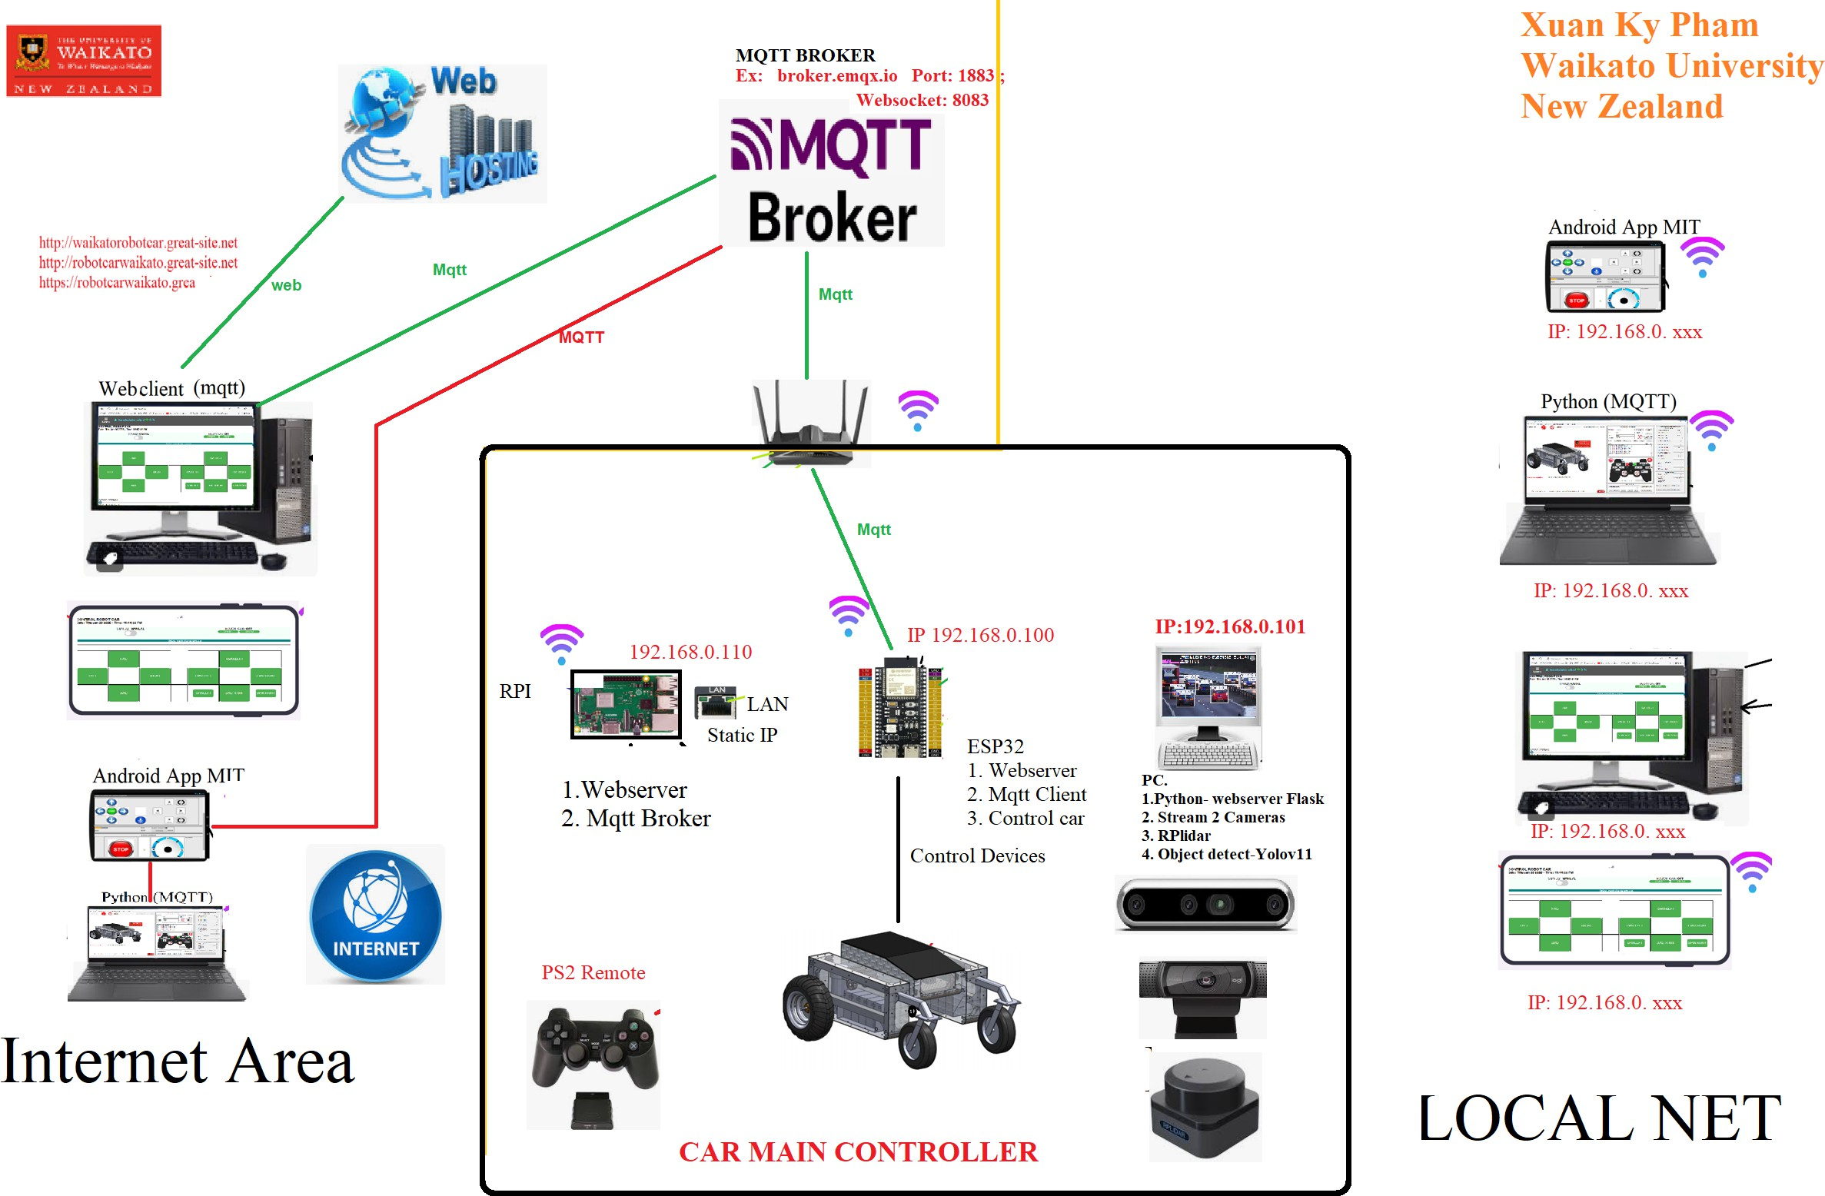

Figure 35: Accessing Webserver of ROBOT Car on the Internet

## Chapter 4 Implementation

### Hardware Assembly

The integration of the robot car’s hardware is crucial for its effective operation, stability, and ensure it runs efficiency. It integrates multiple electronic components, sensors, and actuators to facilitate remote control and autonomous movement functionalities.

#### Wiring and Circuit Design

An efficient and stable communication system integrated into every part is maintained through systematic wiring. The electric design is simple to ensure smooth operation, where the ESP32-S3 microcontroller acts as the CPU and motor driver, receiving command feedback and controlling sensor data acquisition wirelessly. Two DC motors placed on either side of the car are facilitated with movement by the BTS7960 motor driver located at the rear of the car.

The wiring connections include:

Motor Control: Precise speed and direction control adjusted the BSP7960 motor driver is connected to the ESD32-S3 through PWM directional control signals.

Sensor Integration: Ultrasonic sensors to prevent collision are placed at the front and rear side of the robot, while an RPLidar sensor provides 360-degree detection for the obstacles, aiding the car in navigating complex surroundings.

Power Distribution: A regulated power supply that supports reliable voltage for all components is recommended. Being well-regulated, the sources of power supply keep an even voltage level throughout all components to avoid possible injurious effects.

Proper insulation and cable management techniques were implemented to prevent signal interference and unwanted disconnection during operation. The final assembly was tested for stability in terms of all connections before moving on to software development.

### Software Development

A Python-Flask-MQTT-OpenCV framework is used to develop software for the robot car, thus providing the capabilities of real-time data processing, communications, and control.

#### Code Structure

The entire software system is being designed for modularity to allow scalability, easy debugging, and further extension. The main blocks of software include:

Microcontroller Firmware (ESP32-S3): Responsible for motor control, sensor data acquisition, and com- communication with the web app through MQTT.

Web Application (Flask): A user-friendly graphical interface for users to observe and control commands remotely to the robots in real time.

Image Processing Module (OpenCV): The module performs real-time object detection and distance estimation, assisting in navigation.

Communication Middleware (MQTT and WebSockets): This allows convenient data communication between the control interface and the robot.

The software is developed using application-accepted manufacturing best practices to guarantee reliability and real-time performance.

#### Communication over MQTT and WebSocket

For message passing between the ESP32-S3 microcontroller and the web control interface, remote control and real-time data exchange are done through the MQTT protocol. The real-time, low latency updates enabling timely monitoring of engagement and disengagement of the robot’s movement and sensor data are done through WebSocket communication.

The salient features of the communication system are as follows:

Command data from the web app can be transferred to the robot, and feedback from the robot, together with the system status information, is relayed to the user interface.

The proper allocation of QoS levels guarantees that messages reach their destination, notwithstanding shifting network issues.

Real-time capture and visualization of the robot is done through continuous reception of its sensor readings, motor status, and Web application visualization functionalities.

### Algorithm Development

To achieve precise movement control and autonomous navigation, several core algorithms are implemented.

#### PID Control for Motor Speed

A Proportional-Integral-Derivative (PID) controller is used to regulate motor speed, ensuring smooth acceleration, deceleration, and directional adjustments. The PID algorithm works by continuously adjusting motor power based on feedback from the wheel encoders.

The implementation involves:

Proportional Control (P): Adjusts motor speed based on the difference between the desired and actual velocity.

Integral Control (I): Reduces steady-state errors by accounting for past errors over time. Derivative Control (D): Minimizes overshooting by considering the rate of change of error.

The PID controller improves navigation precision, prevents abrupt movements, and maintains smooth operation, even on uneven surfaces.

#### Image Processing for Navigation

Computer vision techniques are integrated to enhance the robot’s navigation capabilities. The OpenCV library is used for:

Object Detection: Identifying obstacles in the robot’s path.

Edge Detection and Contour Analysis: Assisting in path-following algorithms.

Distance Estimation: Determining the proximity of detected objects to ensure safe stopping distances.

By combining image processing with sensor data from the ultrasonic and RPLidar sensors, the robot makes autonomous navigation decisions, improving its adaptability to dynamic environments.

### Data Flow and Communication

A well-structured data flow system ensures that sensor readings, motor commands, and user inputs are processed efficiently.

#### Message Passing Between IoT Devices

The robot’s communication architecture is built around MQTT, enabling efficient message exchange between different IoT components. The message topics include:

Topic public: robotcar/feedback Topic Subscribe: robotcar/control Topic public is the topic for robot car controller ESP32 send data to web client or MQTT client, while Topic Subscribe is for ESP32 read command from MQTT Clients to control robot car movement.

/robot/camera/frame: Sends real-time image frames for processing.

The structured message-passing system ensures low-latency control and accurate data synchronization.

#### Real-Time Feedback Loop

The robot car operates within a closed-loop control system, where real-time sensor feedback continuously informs the PID controller and navigation algorithms. This loop consists of:

Sensor Input: Real-time readings from encoders, ultrasonic sensors, and the RPLidar module. Processing & Decision Making: PID adjustments and object detection processing.

Actuation: Motor speed corrections and path adjustments based on processed data.

User Monitoring & Control: Users can override automatic decisions and manually control the robot when necessary

## Chapter 5 Experimental Setup and Testing

### Description of Test Environment

The robot car test environment was conducted in Waikato University Laboratory, where controlled environments were established to test the system’s performance under various conditions. The laboratory provided a structured environment with pre-determined test tracks, barriers, and varying lighting conditions to test the robot car’s functionality.

The test environment included:

Flat and Uneven Surfaces: To evaluate the adaptability of the PWM-controlled motors on different surfaces.

Obstacle Course: To analyze the performance of ultrasonic sensors and RPLidar in object detection and obstacle avoidance.

Lighting Variations: To evaluate the image processing algorithms under different lighting conditions, i.e., bright, dark, and shadowed areas.

IoT Connectivity Zone: An area that provides a robust Wi-Fi connection for an attempt at using real-time MQTT message communication and WebSocket-based remote control.

The devices guaranteed that the robot car was operated under real-world conditions, allowing for comprehensive performance analysis and validation of functions.

### Performance Analysis

To quantify the performance of the robot car, a series of key performance indicators (KPIs) were established. They include speed accuracy, obstacle avoidance efficiency, response time, and system stability.

#### PS2 Remote Performance Test

Testing the response time of PS2 Remote to main controller ESP32, calculate the time when pressing any button on remote PS2 and the reaction of the robot car.

#### Motor Performance and Current Measurement

Motor performance was investigated by experimenting with the speed accuracy and its response to different PWM signals. The significant tests conducted are:

Speed vs. PWM Analysis: Measuring motor speed at different PWM values (0 to 255) and checking the linearity.

Current Consumption: Noting the current drawn at different speeds to ascertain efficiency and power consumption.

PWM Motor Speed Control: A PID controller was not used for motor speed control and the bst7960.h Arduino library was used instead. PID tuning was difficult due to the lack of ideal parameters, and hence a different direct PWM control-based strategy was attempted.

Results showed that PWM-based control provided precise motor speed change and enabled smooth motor

acceleration and deceleration without requiring PID tuning complexity.

#### Obstacle Detection and Avoidance

The performance of ultrasonic sensors and RPLidar was tested by placing objects at different distances and noting the response time of the robot car in terms of stopping or changing direction. The tests conducted are:

Ultrasonic Sensor Response: Testing the response time for objects within the safety range.

RPLidar C1 Data Accuracy: Verifying 360° obstacle distance readings and their efficiency in stopping the robot.

Edge Cases: Navigation testing in populated areas to observe navigation efficiency.

Results indicated that the sensor fusion approach (RPLidar + ultrasonic sensors) enhanced safety and reduced the possibility of collision.

### Real-Time Response Testing and IoT Connectivity

One key aspect of the robot car is remote control using MQTT and WebSockets. The real-time response of the IoT system was verified through:

Testing MQTT Latency: Sending commands and determining how long it took for the robot to react.0

Checking WebSocket Data Transmission: Ensuring live status updates were displayed on the web interface with minimal delay.

Testing Video Stream on Local Network and NAT Port: Measuring real-time video feed performance and ensuring smooth transmission over local and remote access points.

Management of Network Disruptions: Simulation of poor Wi-Fi signals and watching the system recover.

#### Results

Average MQTT command latency: Measured in milliseconds, response within acceptable limits.

Video Stream Quality: Verifying frame rate and lag when accessing video through local and remote networks.

Data Integrity: No loss of messages seen during consistent network conditions.

Recovery Mechanism: The system recovered seamlessly upon temporary disconnect, never stopping consistently.

### Image Processing Accuracy Assessment

The performance of computer vision algorithms was verified through a comparison of their object detection and distance estimation capabilities.

#### Object Detection and Distance Estimation

Intel RealSense camera utilizing YOLO V10 was utilized for object detection and distance estimation. The following tests were run:

Object Detection Accuracy: Measuring the accuracy of YOLO V10 in detecting objects across different conditions.

Distance Measurement Verification: Confirmation of calculated distances from the camera with actual measurements.

Response Time: Confirmation of the robot’s capability to stop within a reasonable distance when detecting an object.

#### Findings

Object detection accuracy was more than 90

Distance measurement had a total error of less than 5

Process optimizations in terms of frame rates ensured real-time detection with negligible lag.

### Battery Performance Evaluation

Battery performance was evaluated under different conditions to gauge its working life. The key parameters of evaluation were:

Battery Current Consumption at Different Speeds: Measuring current consumption at various PWM levels.

Lab Environment Operation Time: Continuous operation of the robot and observation of the time taken before the batteries are depleted.

Power Efficiency with Sensors On: Gauging the impact of image processing and real-time video transmission on the battery life.

Results showed battery efficiency was optimized for prolonged use, most power-hungry operations including video streaming and motor operation at high speed.

## Chapter 6 Result and Discussion

### System Performance Analysis

System performance was evaluated based on various parameters, including motor control, obstruction detection, image processing accuracy, and IOT connectivity. One of the important aspects of evaluation was motor motion control. Initially, PID control was considered; However, due to difficulty in determining optimal PID parameters, direct motor speed control using PWM was implemented instead. BST7960.H library was used for this purpose, allowing efficient and stable motor speed regulation without the need for complex tuning. The performance of the ultrasonic sensor, RPLIDAR, and Intel RealSense camera was also evaluated to detect obstruction and determine the accuracy of commodity recognition. IOT connectivity, real-time response, and message delays were measured to ensure the system's reliability for distance monitoring and control. Additionally, performance tests were performed to evaluate the effectiveness of various control methods, including:

* PS2 Remote Control: The robot car was manually controlled using the PS2 wireless controller. The reaction time and movement precision were analyzed to determine the accuracy and efficiency of this control method.
* Yolov10 object detection and distance measurement: The accuracy of Yolov10 was evaluated by comparing the approximate distance with real measurements in detecting objects and measuring distance.
* IOT communication response: Delay in message transmission through MQTT was measured under various network conditions to assess real-time accountability.

### Graphs, tables, and comparisons.

All data was collected and analyzed to illustrate the system performance.

**6.2.1. Motor Speed and PWM input.**

|  |  |  |  |  |
| --- | --- | --- | --- | --- |
| **MOTOR SPEED PERFORMANCE** | | | | |
| **PWM** | **RIGHT**  **Speed RPM** | **RIGHT**  **Speed KMh** | **LEFT**  **Speed RPM** | **LEFT**  **Speed Kmh** |
| 0 | 0 | 0 | 0 | 0 |
| 20 | 3 | 0.26 | 4 | 0.26 |
| 30 | 7 | 0.46 | 7 | 0.46 |
| 40 | 10 | 0.65 | 10 | 0.65 |
| 50 | 13 | 0.85 | 13 | 0.85 |
| 60 | 16 | 1.05 | 16 | 1.05 |
| 70 | 20 | 1.31 | 20 | 1.31 |
| 80 | 22 | 1.45 | 22 | 1.45 |
| 90 | 25 | 1.64 | 25 | 1.64 |
| 100 | 28 | 1.84 | 28 | 1.84 |
| 110 | 31 | 2.04 | 31 | 2.04 |
| 120 | 35 | 2.3 | 35 | 2.3 |
| 130 | 39 | 2.57 | 39 | 2.57 |
| 140 | 41 | 2.7 | 41 | 2.7 |
| 150 | 45 | 2.96 | 44 | 2.9 |
| 160 | 48 | 3.23 | 47 | 3.16 |
| 170 | 51 | 3.36 | 50 | 3.29 |
| 180 | 55 | 3.62 | 54 | 3.56 |
| 190 | 59 | 3.82 | 58 | 3.76 |
| 200 | 61 | 4.09 | 60 | 4.02 |
| 210 | 65 | 4.35 | 64 | 4.28 |
| 220 | 69 | 4.48 | 68 | 4.35 |
| 230 | 72 | 4.68 | 70 | 4.61 |
| 240 | 75 | 4.91 | 73 | 4.81 |
| 250 | 79 | 5.14 | 77 | 5.07 |

**Table 9: Measuring speed for left and right motor with PWM input**

This table value illustrates a slight difference between the left and right motor with the same PWM input value. Especially when the PWM range changes higher than 150, the right and left motor speeds have a difference.

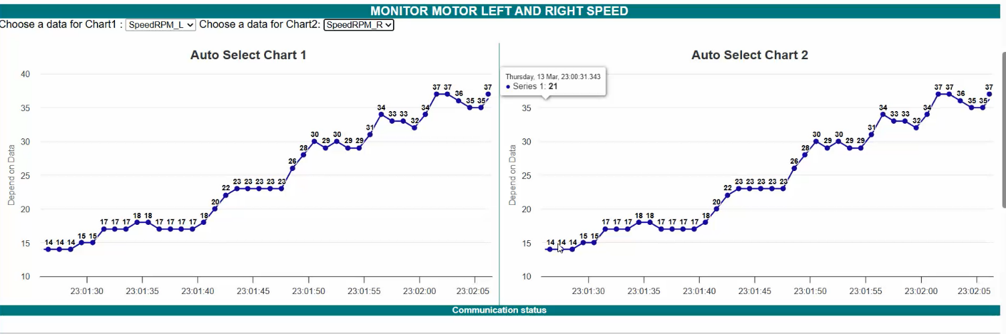

Figure 36: Motor Speed left and right RPM Speed differences from 14RPM to 37 RPM

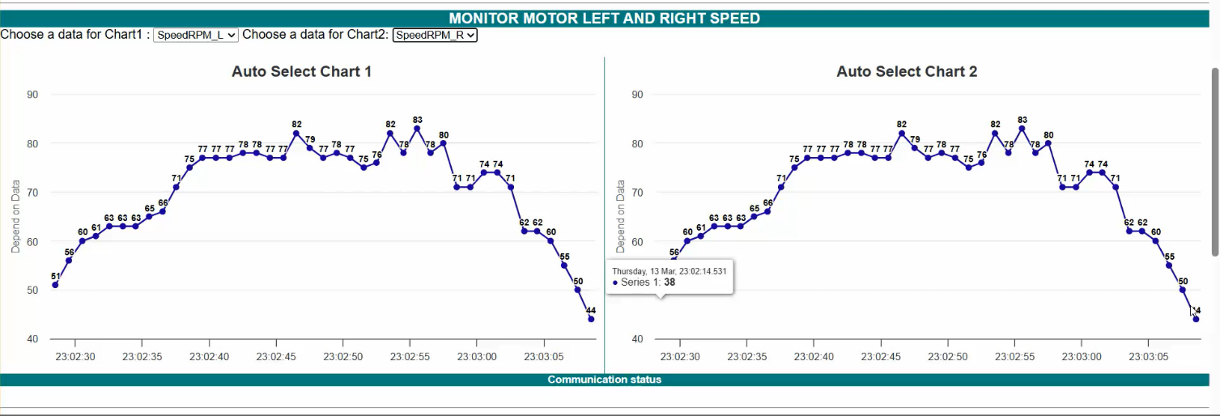

Figure 37: Motor left and right RPM Speed changing

### 6.2.2. ****Obstacle Detection and Distance Accuracy****

By using the YOLO pretrain dataset for detection with a camera from Intel Realsense, we will also measure the distance from the object to the robot and apply this data to stop the robot when the object distance is less than the safety distance set by the user.

This table data measures object distance and the accuracy of object recognition using the minimal Yolov10n.pt dataset, which is the smallest dataset.

|  |  |  |  |
| --- | --- | --- | --- |
| **INTEL REALSENS CAMERA PERFORMANCE TEST** | | | |
| **DISTANCE** | **DISTANCE DETECT Camera** | **CONFIDENCE Object Detection YOLOV10** | Distance Measure Error % |
| 0.5 | 0.521 | 0.98 | -4.20 |
| 1 | 0.982 | 0.96 | 1.80 |
| 1.5 | 1.494 | 0.96 | 0.40 |
| 2 | 1.941 | 0.95 | 2.95 |
| 2.5 | 2.376 | 0.96 | 4.96 |
| 3 | 2.912 | 0.94 | 2.93 |
| 3.5 | 3.399 | 0.96 | 2.89 |
| 4 | 3.854 | 0.95 | 3.65 |
| 4.5 | 4.372 | 0.93 | 2.84 |
| 5 | 4.87 | 0.93 | 2.60 |

Table 10: Intel realsense camera performance test

### 6.2.3 ****PS2 Remote Testing****

### **Performance test PS2 remote, PS2 Remote is tested with in normal operation of Robot car smoothly, the response time of PS2 remote is very fast.**

### **Yahboom 2.4GHz PS2 remote has a signal distance of up to 15 meters and automatically sleeps after 30 seconds if no connection is detected.**

### 

### **Figure 38: Yahboom 2.4 GHz PS2 Remote (https://thinkrobotics.com/products/yahboom-wireless-ps2-controller)**

### ****6.2.4 Ultrasonic sensor distance testing****

|  |  |  |  |  |
| --- | --- | --- | --- | --- |
| **ULTRASONIC SENSOR DISTANCE TEST** | | | | |
| **Distance (m)** | **FWD SENSOR** | **AFT SENSOR** | **Error FWD(%)** | **Error AFT(%)** |
| 0.5 | 0.55 | 0.455 | -10 | 9 |
| 1 | 0.91 | 0.97 | 9 | 3 |
| 1.5 | 1.31 | 1.46 | 12.67 | 2.67 |
| 2 | 1.75 | 2.75 | 12.5 | -37.5 |

### **Table 11: Ultrasonic Sensor performance test**

### 6.2.5 RPlidar testing

### 

### Figure 39: RPlidar performance test

### 6.2.6 Test Operation Robot Using Python Application

### 

### Figure 40: Python interface program used for controlling the robot car

### The robot car is configured to be controlled by MQTT and WebSocket protocols, therefore, it is easy to design any interface such as Python, C#, Android Application, or web pages to control ROBOT. The Python interface is designed by Python and is very attractive; however, it is only can be used on one PC only, and it is not configured as a client or server. A Web Server is more convenient when using a remote-control robot car.

### In this Python program, to control the robot car, Users can set up an MQTT broker before operating the robot. after the configuration is complete, users can operate the robot, display camera 2 cameras, or use Yolo V11 to detect traffic signs and use this data to operate the robot based on the trained dataset below

### 

### Figure 41: Image dataset for traffic signal training.

### Limitations and Improvements

The system has certain limitations even though some of its components have been implemented successfully:  
  
Problems with motor control: PID control is essential for precise speed regulation, which can significantly impact performance in dynamic environments.  
  
Low-Light Object Detection: In low-light conditions, the Intel RealSense camera performs poorly, necessitating possible enhancements such as infrared support. The performance of the camera is also affected by the condition of the environment, which causes the image processing accuracy to be reduced.  
  
Network Dependency: Network stability has an impact on real-time IoT connectivity, which can occasionally cause delays in remote control operations.  
  
Battery Life: Constant sensor activity and video streaming have a substantial impact on battery life, requiring additional optimization.  
  
PS2 Remote Control Range Restrictions: The wireless PS2 controller can only be controlled within a specific range of 15 meters; it is too short if the vehicle is running at high speed.  
  
YOLOv10 Processing Delay: Real-time obstacle avoidance in fast-moving objects is impacted by the object detection algorithm's slight processing delay. The computer used for image processing needs to have high-quality hardware, such as a graphic processing unit GPU and CPU.

**6.4 Future Enhancements:**  
  
An adaptive motor control system can be utilized to enhance speed regulation through partial PID tuning.

Optimization of image algorithms to enhance performance in low light conditions should be done.

Maximize power consumption by reducing unnecessary processing loads and improving data update intervals.

Decrease response time and object detection latency by improving YOLOv10 processing.

Broaden the manual control range by integrating a Bluetooth control system or a high-range wireless controller.

Find the Arduino program algorithm for GPS Position control for robot car.

Improve the traffic signal dataset and use this dataset for controlling robot operation by using the new version of YOLO V12 update in April 2025.

## Chapter 7 Conclusion and Future Work

### Conclusion

### This study concentrated on creating and testing a smart robot car that combines image processing, MQTT communication, and the Internet of Things (IoT). The primary goal was to develop a system that could navigate on its own, identify obstacles using a variety of sensors, and allow for remote control and monitoring via a web-based platform.

### Software development, system performance testing, and hardware integration all saw notable advancements during the project. To guarantee precise object detection and distance measurement, the robot car was outfitted with a number of sensors, including RPLidar, an Intel RealSense camera, and ultrasonic modules. WebSocket and the MQTT protocol were used to enable real-time communication between the robot and distant users.

### Direct PWM control using the BSt7960 library eventually took the place of PID control, which was first thought to be an option for precise motor speed management because PID tuning proved to be challenging. The motor's performance stayed steady and dependable in spite of this alteration. A number of testing scenarios were carried out, such as MQTT-based communication latency evaluations, object detection accuracy using YOLOv10, and remote control using a PS2 controller.

### The outcomes showed that the system works and satisfies the majority of the design requirements. In addition to responding to commands in real time and successfully avoiding obstacles, the robot car also streamed live video for remote monitoring. The system can still be improved, though, particularly in the areas of energy efficiency, accurate low-light detection, and reliable wireless communication.

### Long-range wireless connection LORA communication is configured to communicate or control robot car to eliminate the limit distance signal transmit of PS2 remote, however due to the limitation of time, LORA in this project is not designed as a remote handheld but it is connected with remote PC running python application to monitor and control robot over LORA network.

### Future works

### Although the project's main goals have been met, there are still a number of chances for advancements and improvements in the future:

### Improved Motor Control: By implementing simplified tuning techniques or adaptive control strategies, motor speed regulation and navigation performance may be improved.

### Better Image Processing: Reliability would be increased by improving the vision system's ability to function well in a range of lighting conditions, perhaps with the use of infrared sensors or better low-light cameras.

### Power Optimization: Increasing battery efficiency and effectively controlling power consumption can extend operating time, particularly for tasks requiring a lot of processing.

### Improved connectivity in outdoor or large-area applications can be achieved by integrating extra wireless communication technologies like LTE, or Wi-Fi mesh networks.

### Object Tracking and Path Planning: Putting algorithms in place to monitor moving objects and modify the robot's

## References

1. Robot Car with Arduino https://awant.medium.com/building-a-robot-car-6a707873b882.
2. YOLO, “Yolo v11 object detection.” https://docs.ultralytics.com/

[3] MQTT organization website: https://mqtt.org/

[4] Definition of MQTT source: https://aws.amazon.com/what-is/mqtt/)

[5] MQTT Over WebSocket source : https://www.emqx.com/en/blog/connect-to-mqtt-broker-with-websocket

[6] Definition of WebSocket source https://ably.com/topic/mqtt-vs-websocket

[7] Single Shot Detectors (SSDs) [https://www.baeldung.com/](http://www.baeldung.com/)

[8] Convolutional neural network (CNN) https://www.techtarget.com/searchenterpriseai/definition/convolutional-neural- network

[9] ESP32 S3 Datasheet <https://www.espressif.com/sites/default/files/documentation/esp32-s3-wroom-1_>wroom-1u_ [datasheet_en.pdf](https://www.espressif.com/sites/default/files/documentation/esp32-s3-wroom-1_wroom-1u_datasheet_en.pdf)

[10] RPlidar Specification <https://www.waveshare.com/wiki/RPLIDAR_C1>

[11] Depth Camera intel realsens datasheet <https://www.intelrealsense.com/download/21345/?tmstv=1697035582>

[12] DC Motor Driver BST-7960 : [https://www.handsontec.com/dataspecs/module/BTS7960%20Motor%20Driver.pdf](http://www.handsontec.com/dataspecs/module/BTS7960%20Motor%20Driver.pdf)

[13] ESP32 specification <https://www.espressif.com/sites/default/files/documentation/esp32-s3-wroom-1_>wroom-1u_ [datasheet_en.pdf](https://www.espressif.com/sites/default/files/documentation/esp32-s3-wroom-1_wroom-1u_datasheet_en.pdf)

[14] PS2 Remote specification <https://category.yahboom.net/products/yahboom-ps2-handle-controller>

[15] Lora Ebyte specification- https://www.cdebyte.com/news/580

[16 ]IoT Spectrum in New Zealand - <https://iotalliance.org.nz/wp-content/uploads/sites/4/2019/05/IoT-Spectrum-in-NZ-Briefing-Paper.pdf>

[17] Arduino IDE programming - <https://docs.arduino.cc/programming/>

[18] Python Programming - <https://en.wikipedia.org/wiki/Python_(programming_language>

[19] Visual Studio Code programming- [https://en.wikipedia.org/wiki/Visual*StudioCode*](https://en.wikipedia.org/wiki/VisualStudioCode)

[20] MIT Application for Android programming - <https://appinventor.mit.edu/explore/about-us.html>

[21]

**8.Appendices**

**1. RPlidar data:**

**Angle: (Deg)**

[0, 1, 2, 3, 4, 5, 6, 7, 8, 9, 10, 11, 12, 13, 14, 15, 16, 17, 18, 19, 20, 21, 22, 23, 24, 25, 26, 27, 28, 29, 30, 31, 32, 33, 34, 35, 36, 37, 38, 39, 40, 41, 42, 43, 44, 45, 46, 47, 48, 49, 50, 51, 52, 53, 54, 55, 56, 57, 58, 59, 60, 61, 62, 63, 64, 65, 66, 67, 68, 69, 70, 71, 72, 73, 74, 75, 76, 77, 78, 79, 80, 81, 82, 83, 84, 85, 86, 87, 88, 89, 90, 91, 92, 93, 94, 95, 96, 97, 98, 99, 100, 101, 102, 103, 104, 105, 106, 107, 108, 109, 110, 111, 112, 113, 114, 115, 116, 117, 118, 119, 120, 121, 122, 123, 124, 125, 126, 127, 128, 129, 130, 131, 132, 133, 134, 135, 136, 137, 138, 139, 140, 141, 142, 143, 144, 145, 146, 147, 148, 149, 150, 151, 152, 153, 154, 155, 156, 157, 158, 159, 160, 161, 162, 163, 164, 165, 166, 167, 168, 169, 170, 171, 172, 173, 174, 175, 176, 177, 178, 179, 180, 181, 182, 183, 184, 185, 186, 187, 188, 189, 190, 191, 192, 193, 194, 195, 196, 197, 198, 199, 200, 201, 202, 203, 204, 205, 206, 207, 208, 209, 210, 211, 212, 213, 214, 215, 216, 217, 218, 219, 220, 221, 222, 223, 224, 225, 226, 227, 228, 229, 230, 231, 232, 233, 234, 235, 236, 237, 238, 239, 240, 241, 242, 243, 244, 245, 246, 247, 248, 249, 250, 251, 252, 253, 254, 255, 256, 257, 258, 259, 260, 261, 262, 263, 264, 265, 266, 267, 268, 269, 270, 271, 272, 273, 274, 275, 276, 277, 278, 279, 280, 281, 282, 283, 284, 285, 286, 287, 288, 289, 290, 291, 292, 293, 294, 295, 296, 297, 298, 299, 300, 301, 302, 303, 304, 305, 306, 307, 308, 309, 310, 311, 312, 313, 314, 315, 316, 317, 318, 319, 320, 321, 322, 323, 324, 325, 326, 327, 328, 329, 330, 331, 332, 333, 334, 335, 336, 337, 338, 339, 340, 341, 342, 343, 344, 345, 346, 347, 348, 349, 350, 351, 352, 353, 354, 355, 356, 357, 358, 359]

**Distance (mm)**

[881.25, 882.75, 884.75, 886.25, 886.5, 890.0, 890.75, 893.25, 895.75, 897.5, 901.5, 903.5, 909.0, 910.75, 913.5, 922.75, 923.75, 931.25, 934.5, 942.75, 946.5, 951.25, 962.25, 966.75, 977.75, 982.0, 991.75, 998.75, 1005.75, 1017.0, 1025.0, 1039.0, 1047.0, 1066.5, 1076.75, 1099.25, 1110.0, 1120.75, 1142.5, 1151.75, 1172.75, 0.0, 0.0, 781.0, 775.0, 777.25, 799.75, 812.75, 842.5, 858.25, 888.0, 905.0, 919.5, 942.5, 955.25, 969.5, 1618.5, 1685.5, 1720.75, 1758.75, 1836.25, 1877.75, 1925.75, 1974.5, 600.5, 593.75, 581.5, 571.75, 569.5, 0.0, 532.5, 530.25, 0.0, 0.0, 477.0, 460.75, 457.25, 455.75, 454.5, 452.75, 452.0, 451.5, 445.5, 442.75, 441.25, 441.5, 447.5, 454.75, 464.0, 514.75, 0.0, 4508.25, 4510.5, 4513.5, 4520.0, 4549.25, 4579.0, 4616.5, 4625.5, 4874.5, 4902.75, 4926.75, 0.0, 0.0, 0.0, 0.0, 0.0, 0.0, 0.0, 2241.75, 0.0, 0.0, 0.0, 2883.0, 2843.75, 2865.75, 2887.75, 2900.75, 0.0, 1454.5, 0.0, 0.0, 1740.5, 1735.75, 988.5, 979.75, 939.25, 924.0, 914.5, 0.0, 870.5, 851.0, 837.25, 822.25, 799.75, 784.25, 0.0, 763.0, 729.5, 726.5, 2123.25, 2107.25, 2090.5, 2063.25, 0.0, 1771.25, 1766.75, 1821.25, 1812.5, 1822.5, 1819.25, 1796.5, 1798.5, 4376.25, 4426.75, 4449.75, 4510.5, 4530.75, 0.0, 4328.0, 4297.75, 4284.25, 4255.25, 4239.0, 4225.75, 4202.25, 0.0, 0.0, 0.0, 0.0, 0.0, 0.0, 0.0, 4056.75, 4059.5, 4059.75, 4056.75, 4053.25, 4055.75, 4054.0, 4057.25, 0.0, 0.0, 0.0, 0.0, 43.25, 0.0, 2239.0, 0.0, 2122.75, 0.0, 0.0, 0.0, 13827.5, 0.0, 0.0, 2140.75, 0.0, 0.0, 0.0, 1739.75, 1688.75, 1639.25, 1549.5, 1508.25, 1434.25, 1401.5, 1370.5, 1311.5, 1281.5, 1233.5, 1211.25, 1167.75, 1144.75, 1124.0, 1084.75, 1066.0, 938.75, 926.5, 899.25, 885.5, 874.5, 852.0, 842.75, 820.5, 812.0, 803.75, 784.5, 776.5, 760.5, 754.5, 740.0, 733.25, 724.0, 718.5, 713.5, 703.75, 699.0, 690.25, 685.0, 676.0, 671.5, 667.0, 659.25, 653.75, 646.25, 642.75, 634.0, 629.75, 628.25, 621.75, 621.0, 618.25, 616.75, 613.5, 612.25, 610.0, 605.5, 603.25, 602.25, 602.75, 599.25, 598.25, 597.75, 595.25, 595.25, 593.25, 593.0, 592.5, 591.75, 592.5, 593.5, 594.25, 595.0, 595.5, 596.0, 596.5, 598.0, 600.0, 602.25, 602.75, 604.5, 609.0, 611.25, 614.25, 616.25, 620.5, 623.25, 626.0, 631.5, 633.5, 640.0, 643.25, 649.0, 653.5, 656.75, 664.5, 670.0, 679.0, 683.5, 687.75, 698.5, 704.0, 715.75, 721.25, 733.25, 740.5, 746.5, 759.75, 766.75, 780.5, 788.0, 796.75, 816.5, 825.5, 848.0, 859.25, 880.5, 893.5, 920.0, 934.0, 947.25, 977.25, 994.0, 1057.25, 1060.75, 1053.75, 1033.25, 1024.0, 1016.0, 1002.5, 996.25, 984.25, 979.5, 969.0, 963.5, 958.75, 949.75, 945.75, 935.75, 931.0, 927.0, 919.25, 916.5, 909.75, 907.75, 901.75, 899.25, 897.5, 894.75, 892.75, 890.0, 888.75, 884.75, 883.5, 883.0, 882.0, 882.75, 882.0, 881.5]

**RPlidar Angle and Distance Picture**

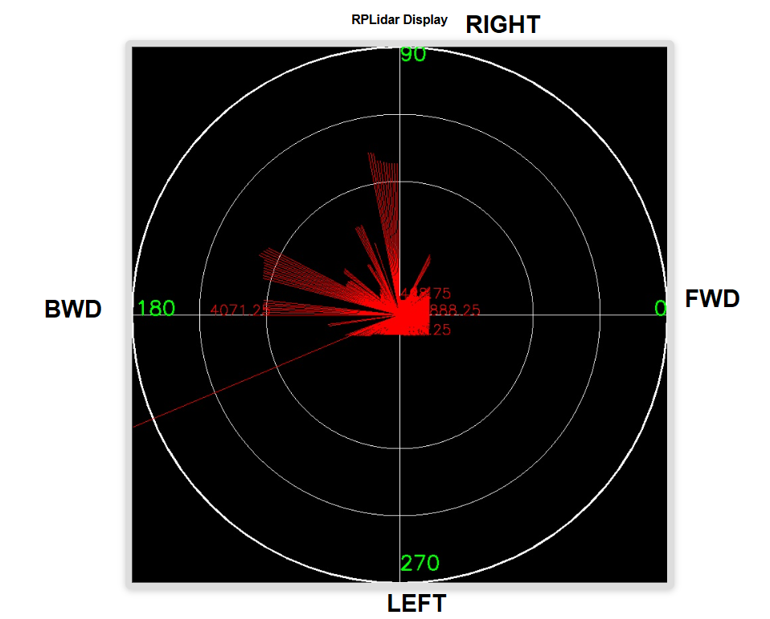

**Arduino Main Program**

Arduino Program